In this project we build a serverless app to process real-time data streams. You’ll build infrastructure for a fictional ride-sharing company. In this case, you will enable operations personnel at a fictional Wild Rydes headquarters to monitor the health and status of their unicorn fleet. Each unicorn is equipped with a sensor that reports its location and vital signs.

To build the applications, we make use of following AWS services:

1. AWS Lambda to process real-time streams.
2. Amazon DynamoDB to persist records in a NoSQL database.
3. Amazon Kinesis Data Analytics to aggregate data.
4. Amazon Kinesis Data Firehose to archive the raw data to Amazon S3.
5. Amazon Athena to run ad-hoc queries against the raw data.

The Project is divided into 4 parts:

1. **Build a data stream**

Create a stream in Kinesis and write to and read from the stream to track Wild Rydes unicorns on the live map. In this module you'll also create an Amazon Cognito identity pool to grant live map access to your stream.

1. **Aggregate data**

Build a Kinesis Data Analytics application to read from the stream and aggregate metrics like unicorn health and distance traveled each minute.

1. **Process streaming data**

Persist aggregate data from the application to a backend database stored in DynamoDB and run queries against those data.

1. **Store & query data**

Use Kinesis Data Firehose to flush the raw sensor data to an S3 bucket for archival purposes. Using Athena, you'll run SQL queries against the raw data for ad-hoc analyses.

**Application Architecture**

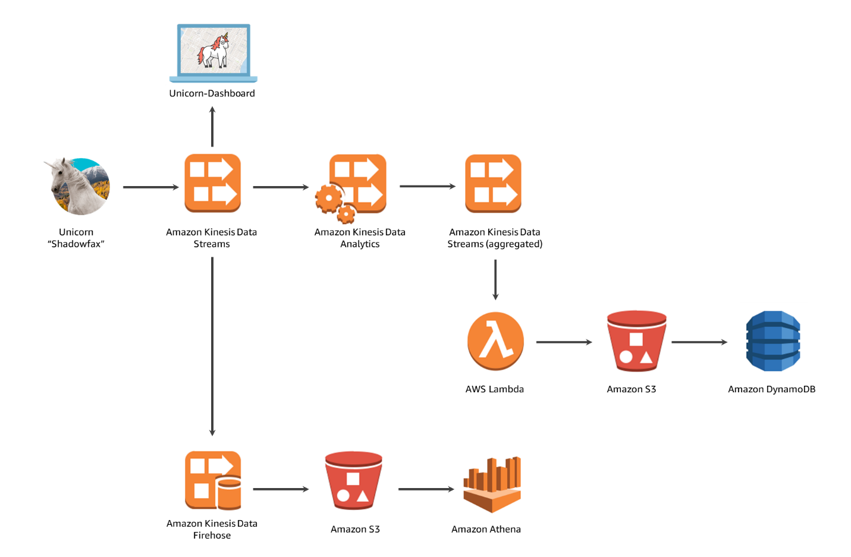

**Module 1: Build a Stream**

We create an AWS Kinesis stream to collect and store data from the unicorn feet. Through the AWS Cloud9 environment, we produce the stream of data by running the producer. This emits every second a message and prints a period to the screen. We can monitor the stream in the Kinesis stream we created through the monitoring section.

Once the stream is being produce, we need to read the stream. In the AWS Cloud9 environment, run the consumer which starts reading sensor data and we get list of messages being produced by the producer.

Now that the stream is being produced and read, we need to grant user access to read the Kinesis stream through the AWS Cognito services by creating an Identity Pool and referencing our Kinesis stream created. Once the AWS Cognito Identity Pool is created, we need to create an IAM Role in Kinesis service by creating a policy that gives read and list permissions to the kinesis stream created.

Now that we have stream which is generating data and access have been given to read the data, we have viewed the stream online via the Unicorn Dashboard by linking it with the Coginto Identity Pool ID. Once done, we will be able to see the Unicorn on the map originating from New York.

We can add more Unicorns/streams by adding another producer stream through AWS Cloud9 environment.

Thus we have successfully created the Amazon Kinesis stream and have visualized it through the fleets of unicorns.

Screenshots:

Create the AWS Cloud9 environment

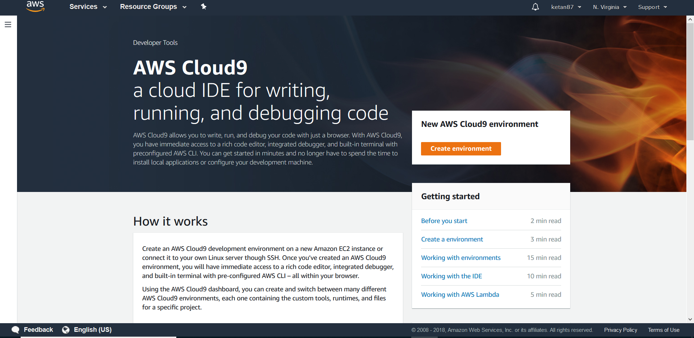

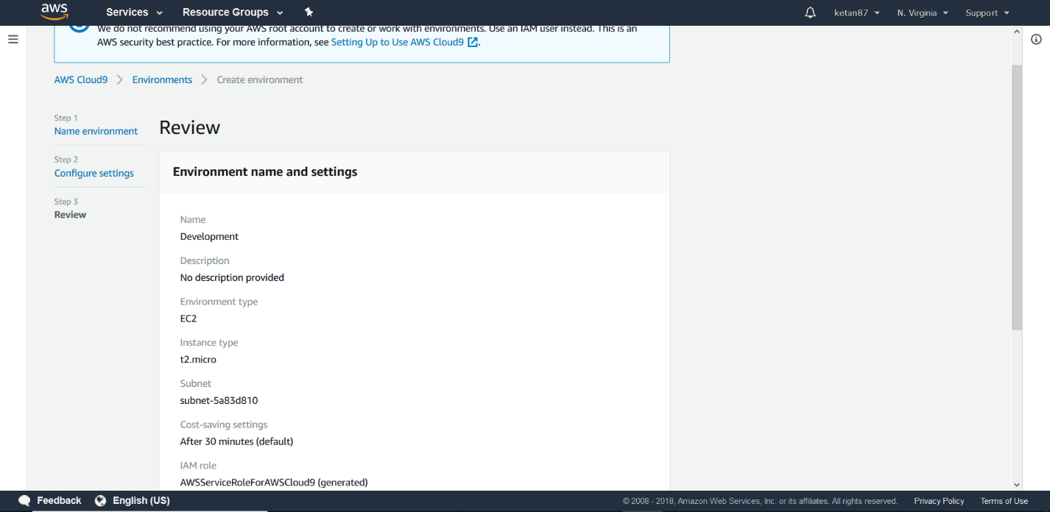

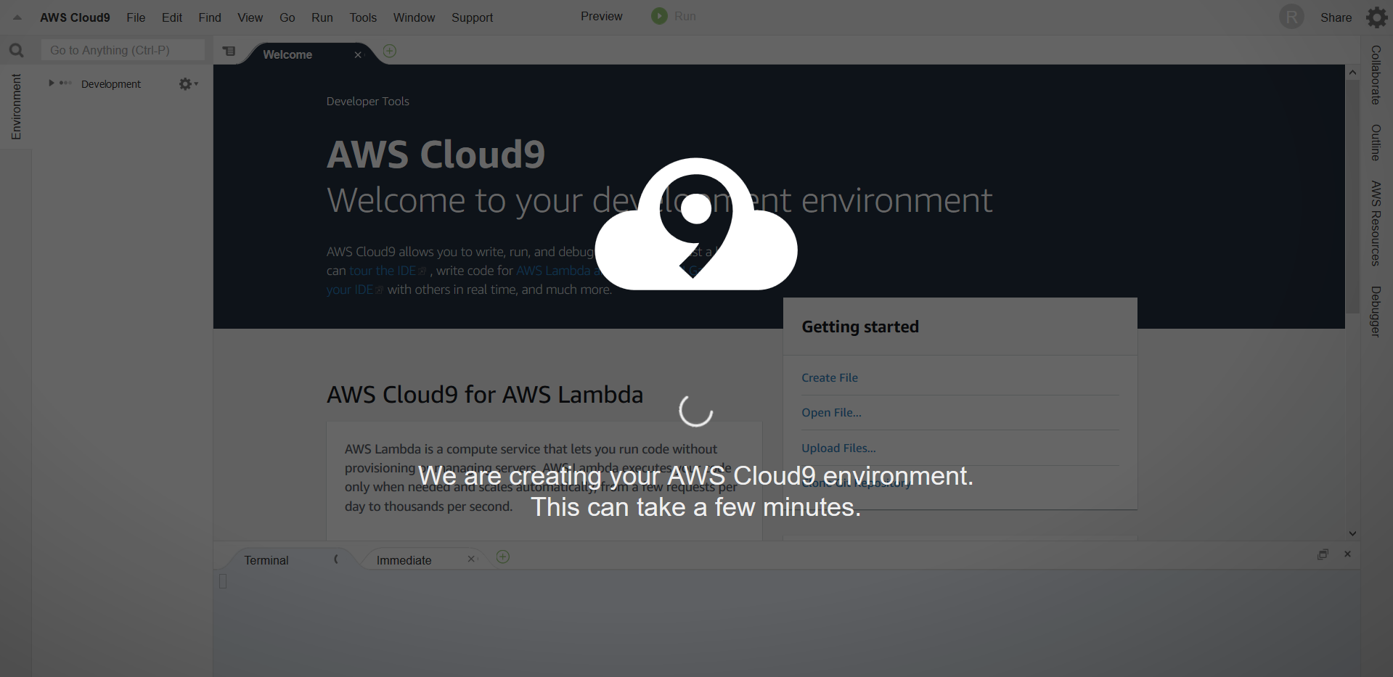

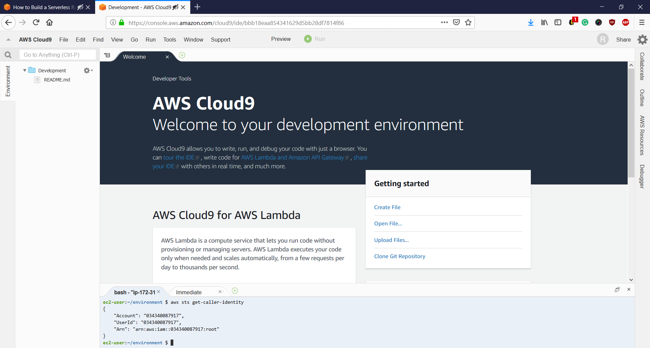

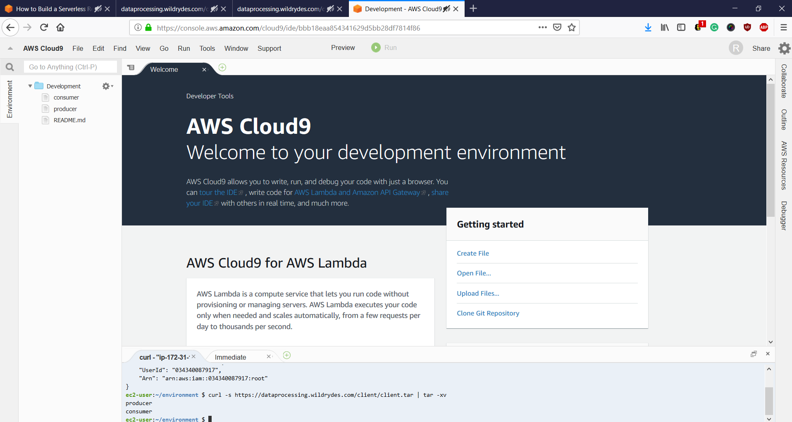

Create a Kinesis Stream

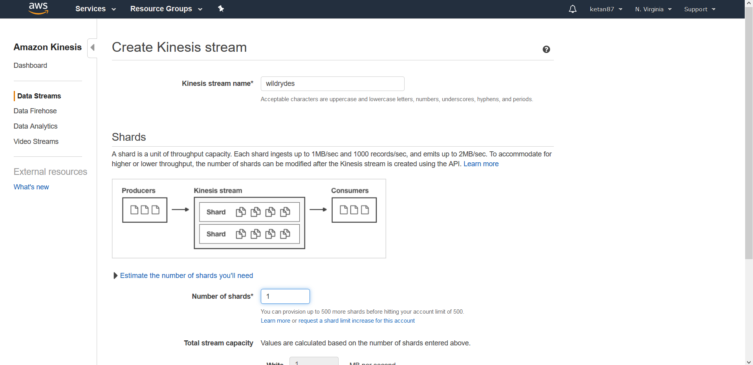

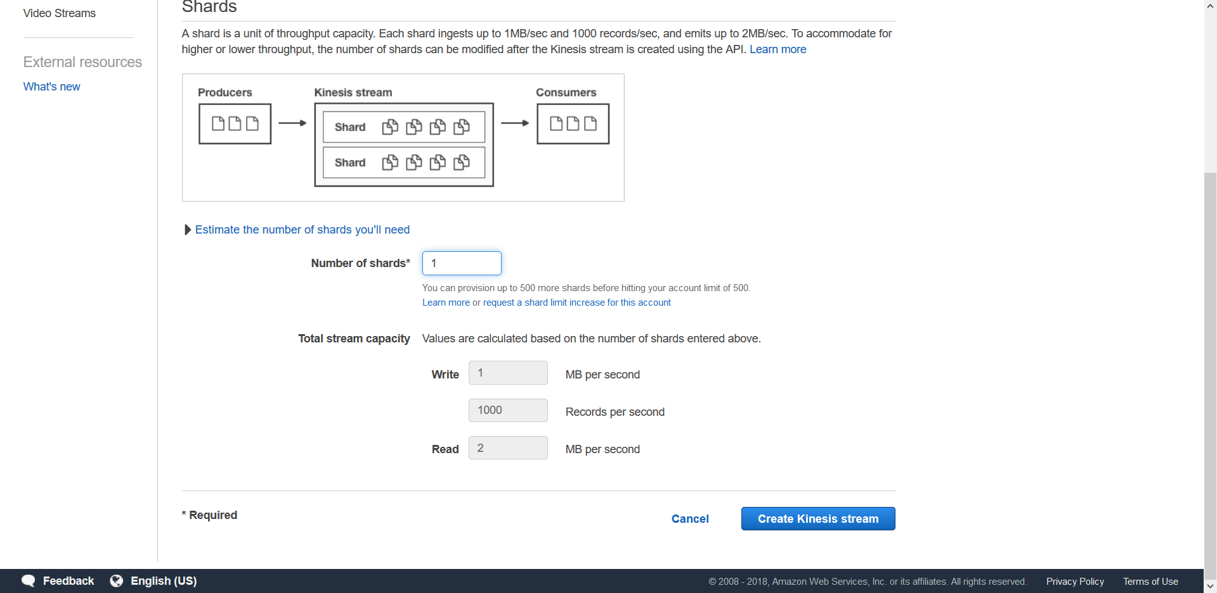

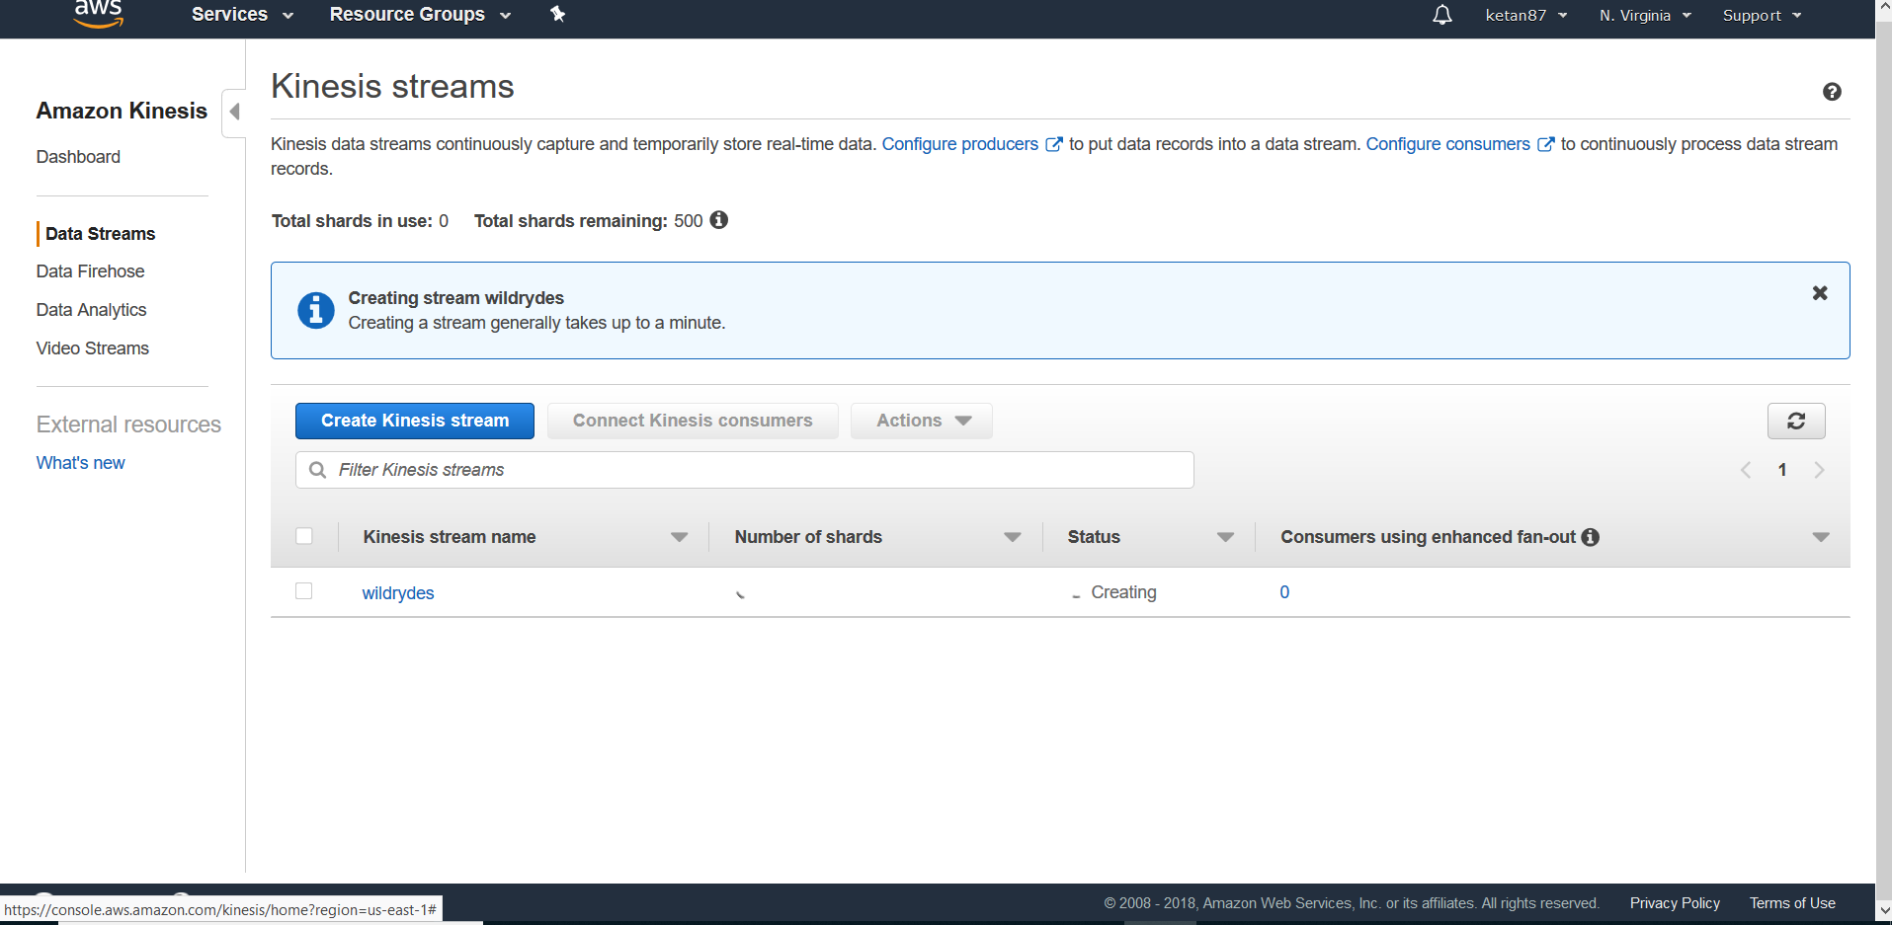

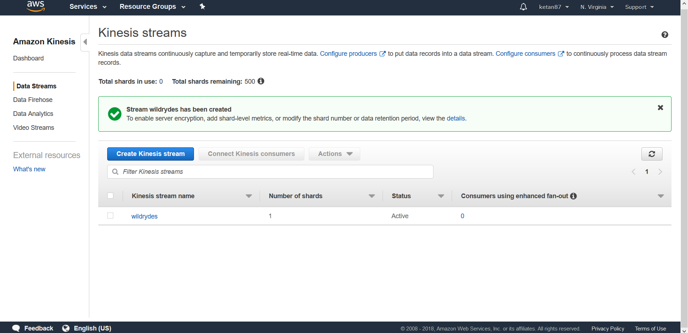

Generating the stream

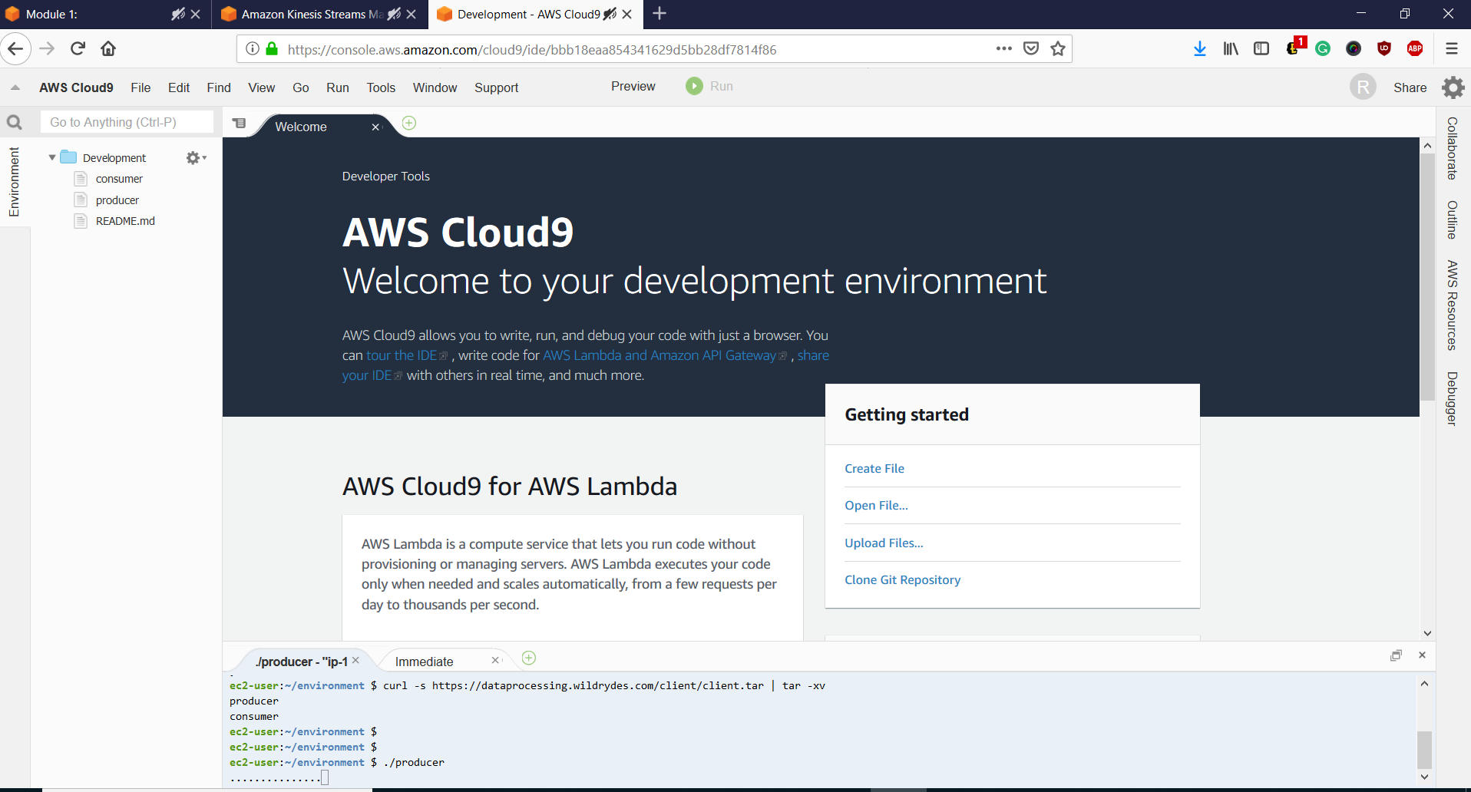

Monitoring the stream in CloudWatch

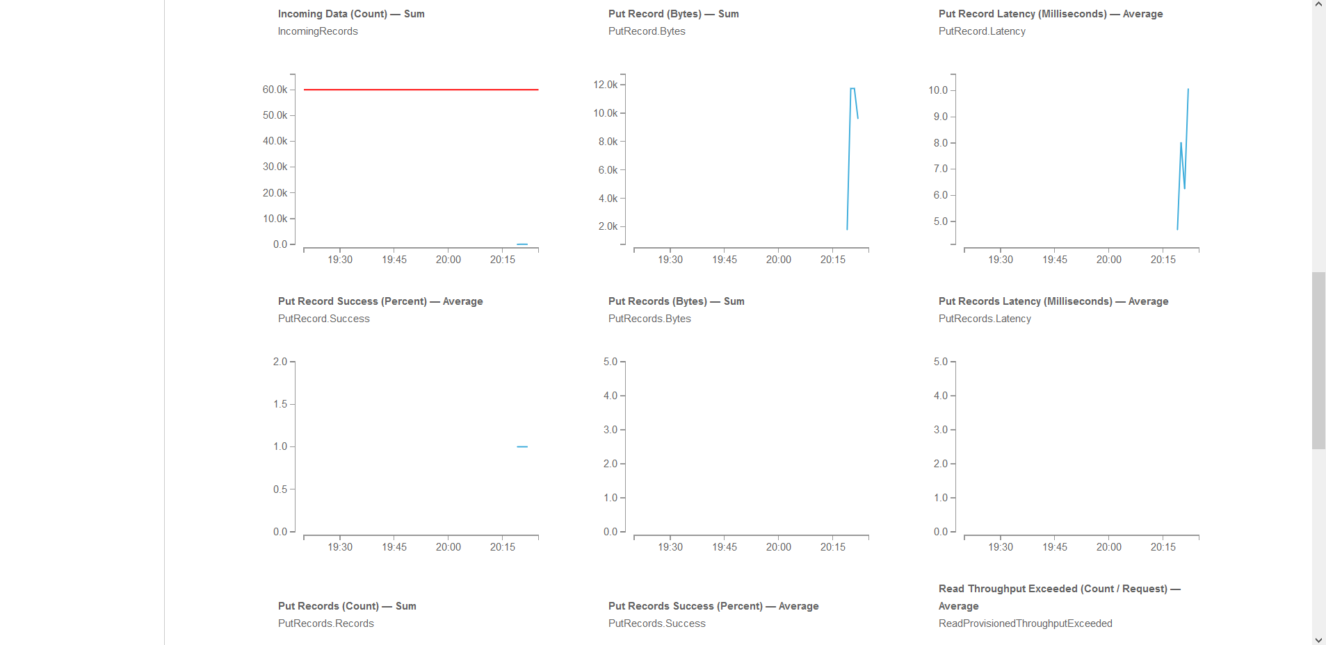

Reading the stream

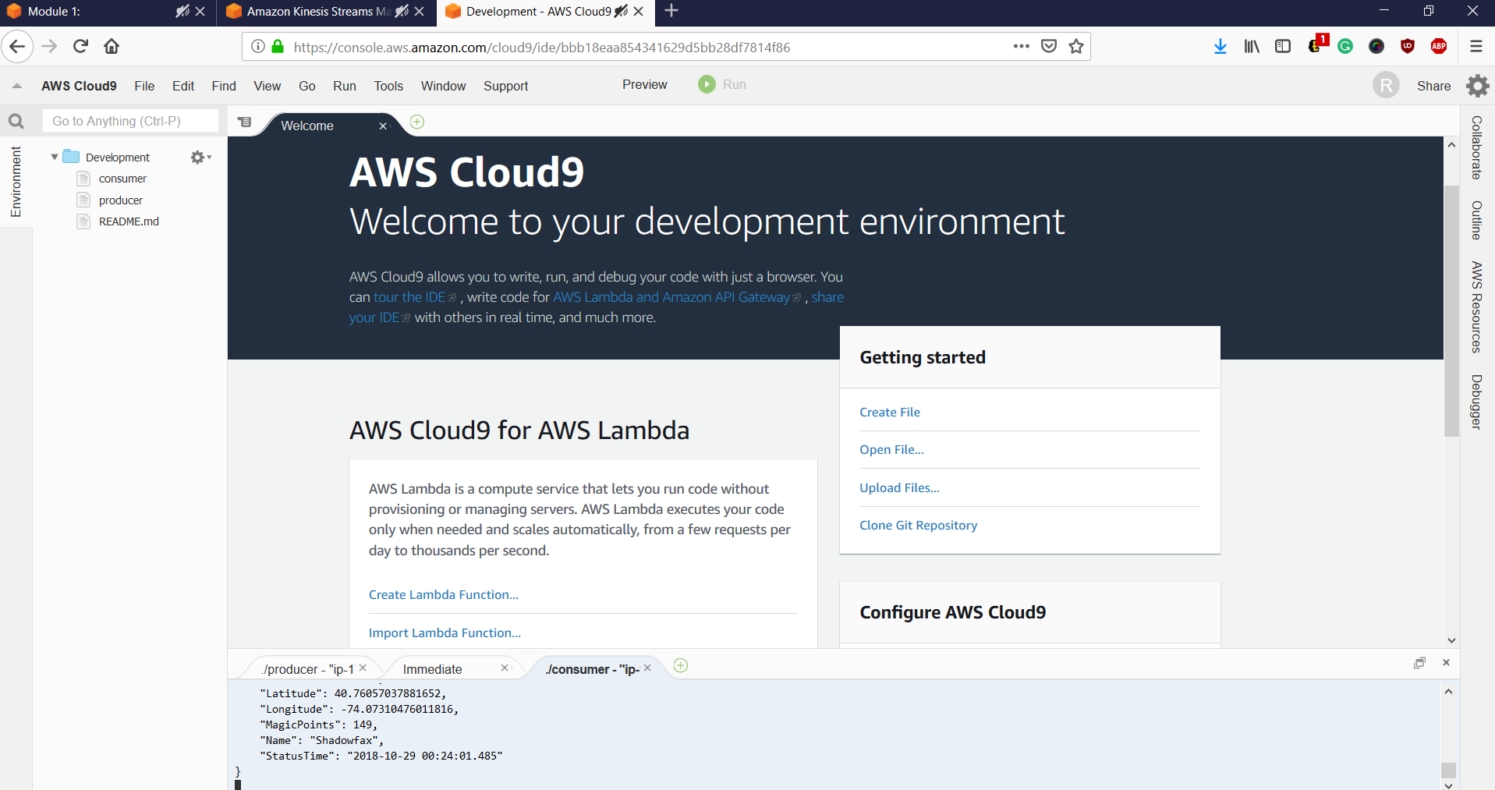

Create an identity pool for the unicorn dashboard

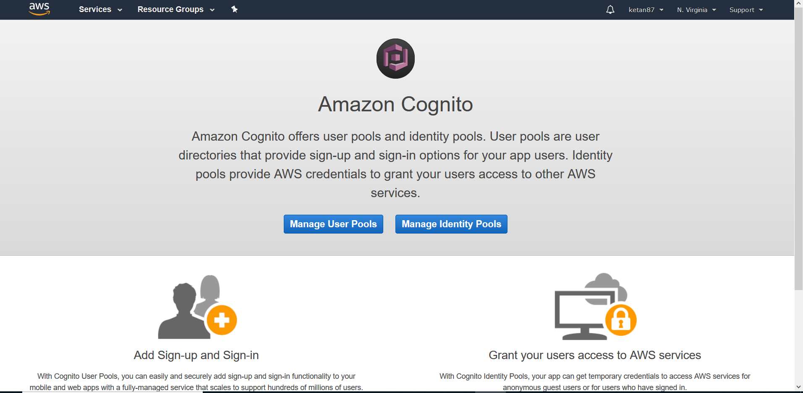

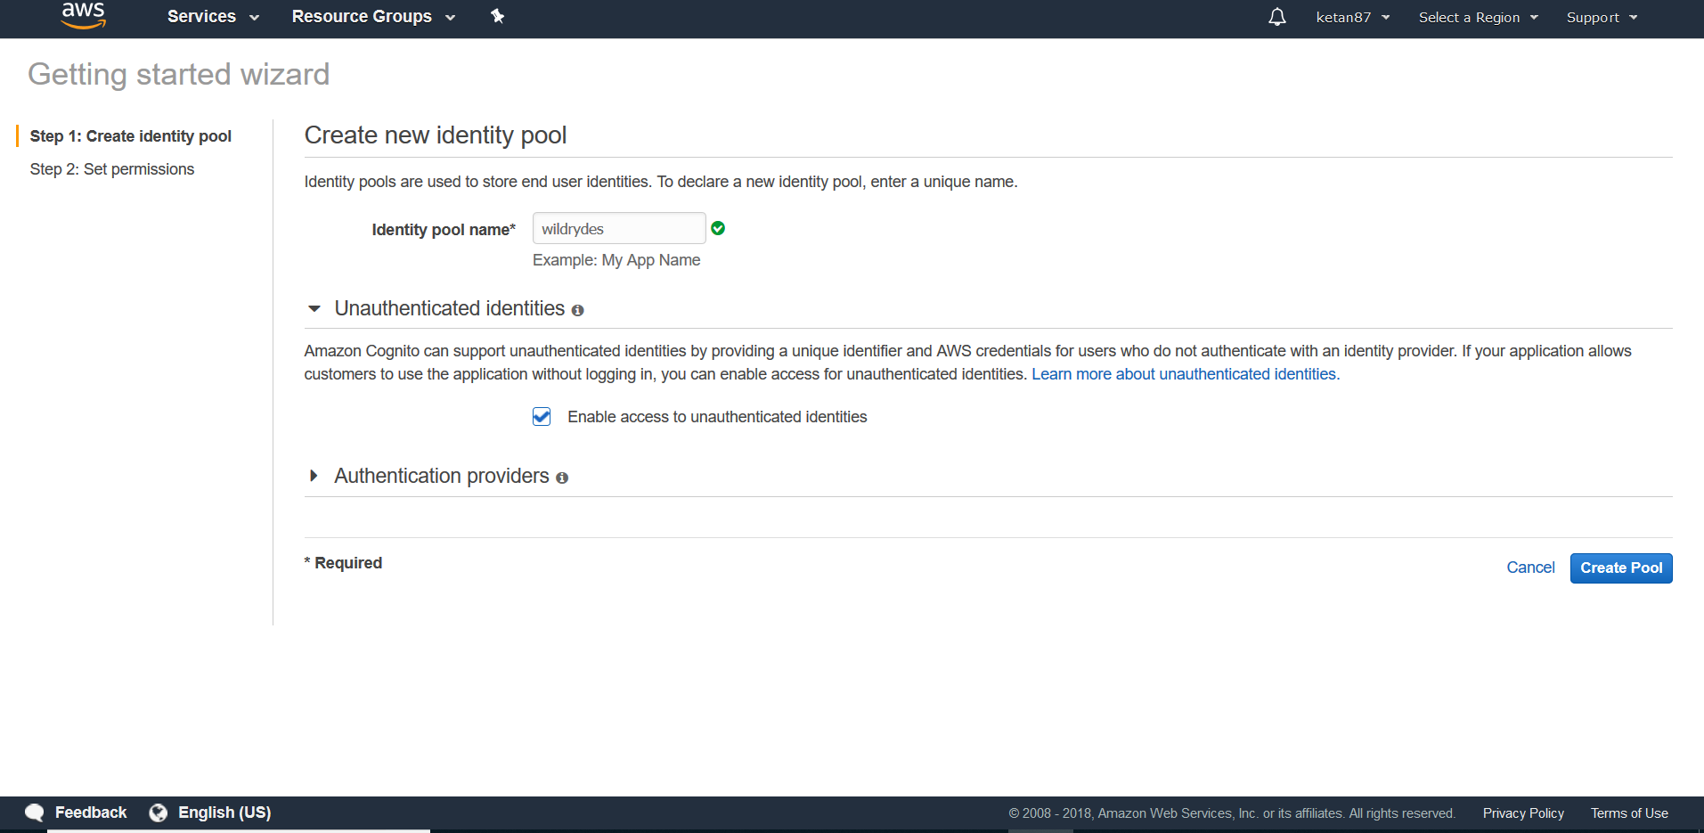

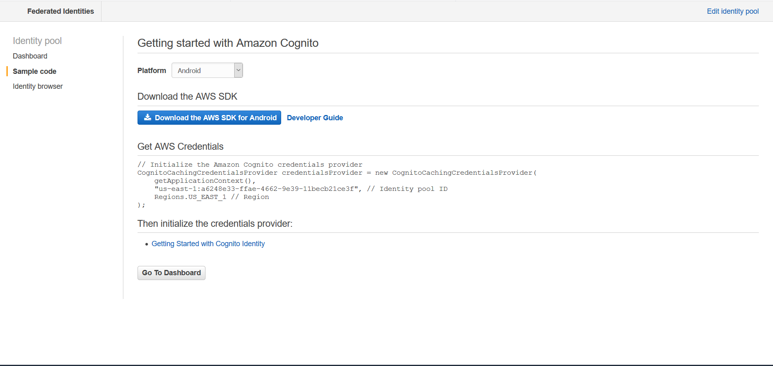

Grant the unauthenticated role access to the stream

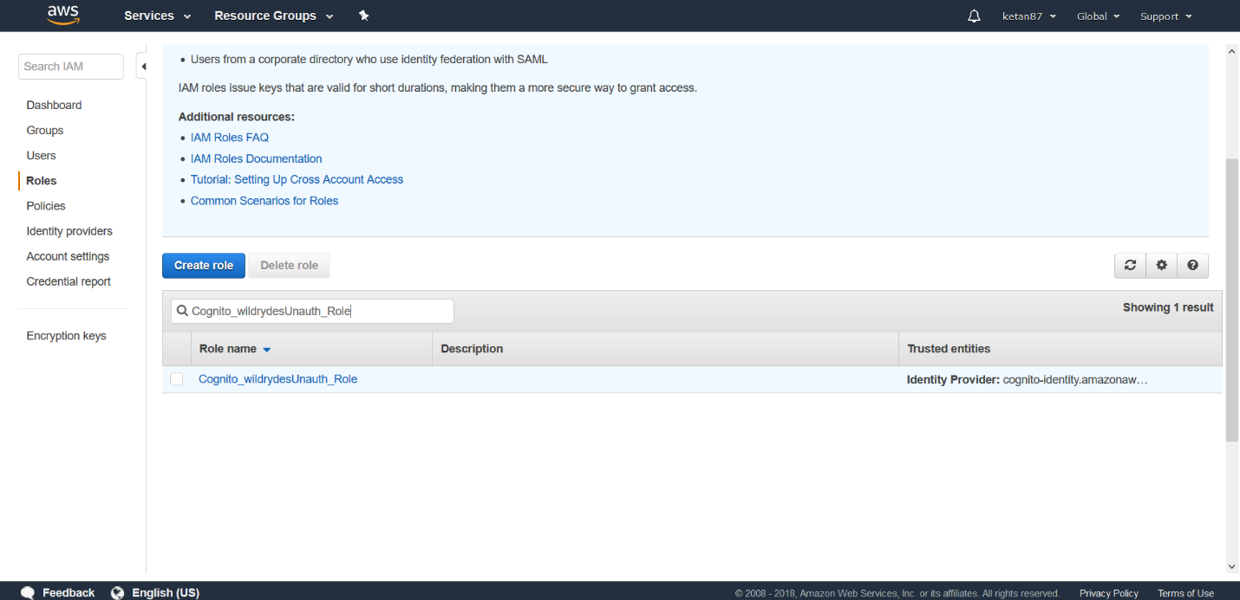

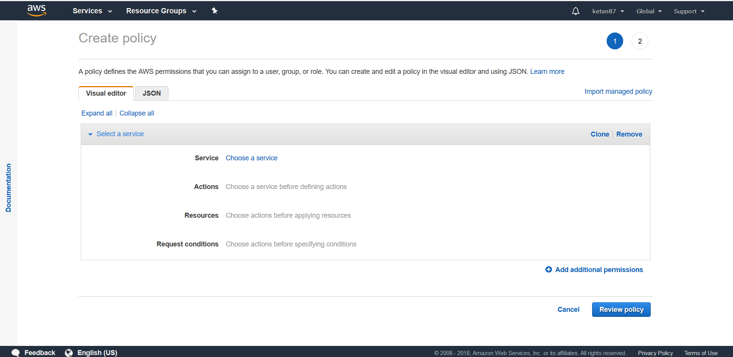

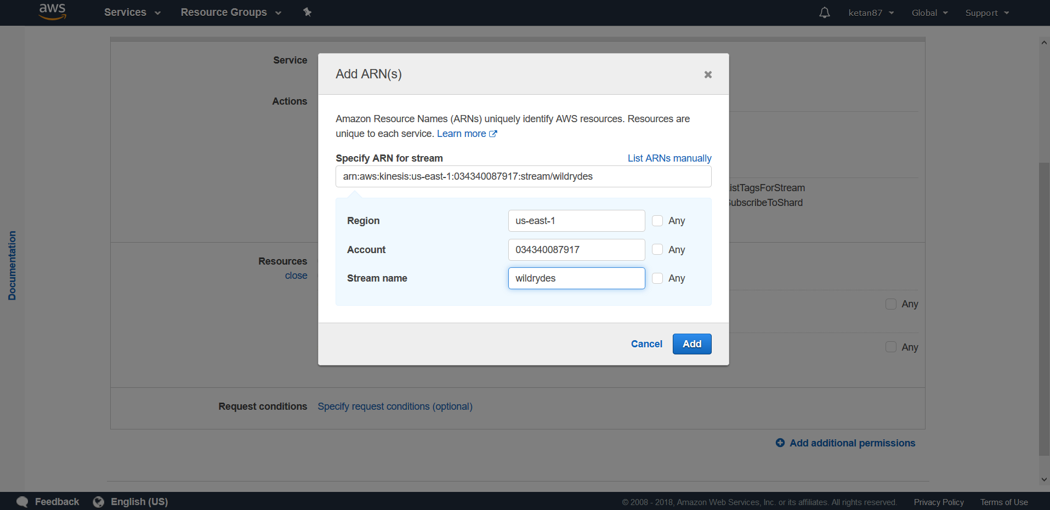

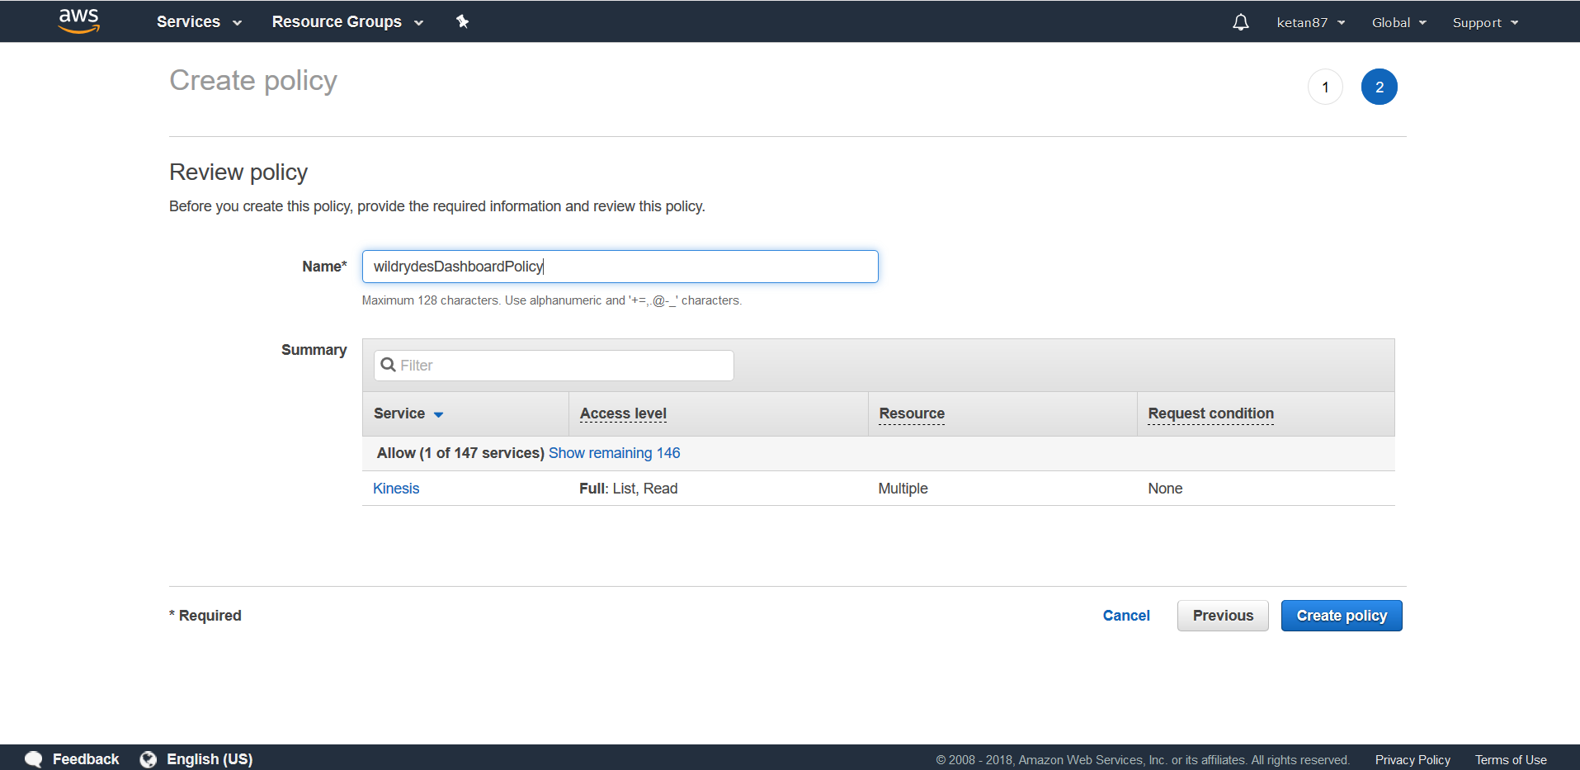

View unicorn status on the dashboard

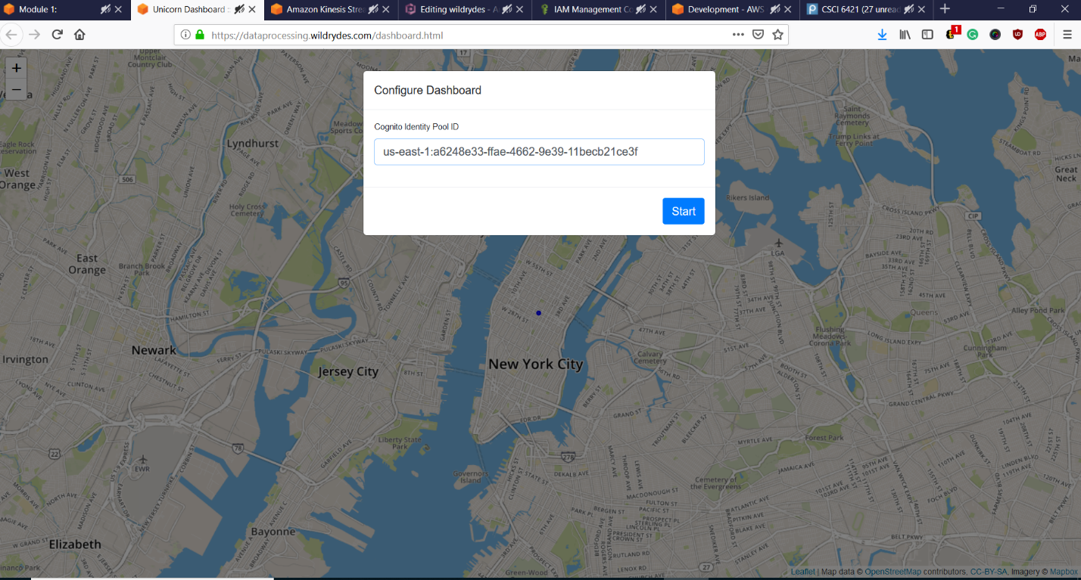

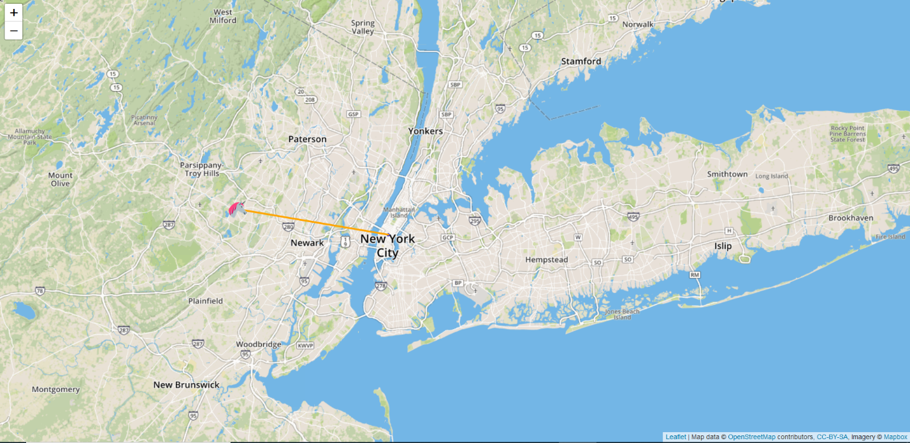

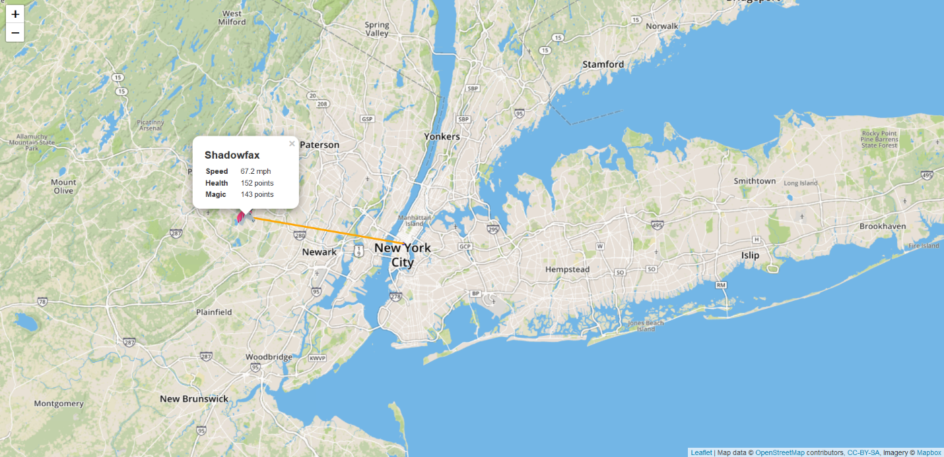

Experiment with the producer

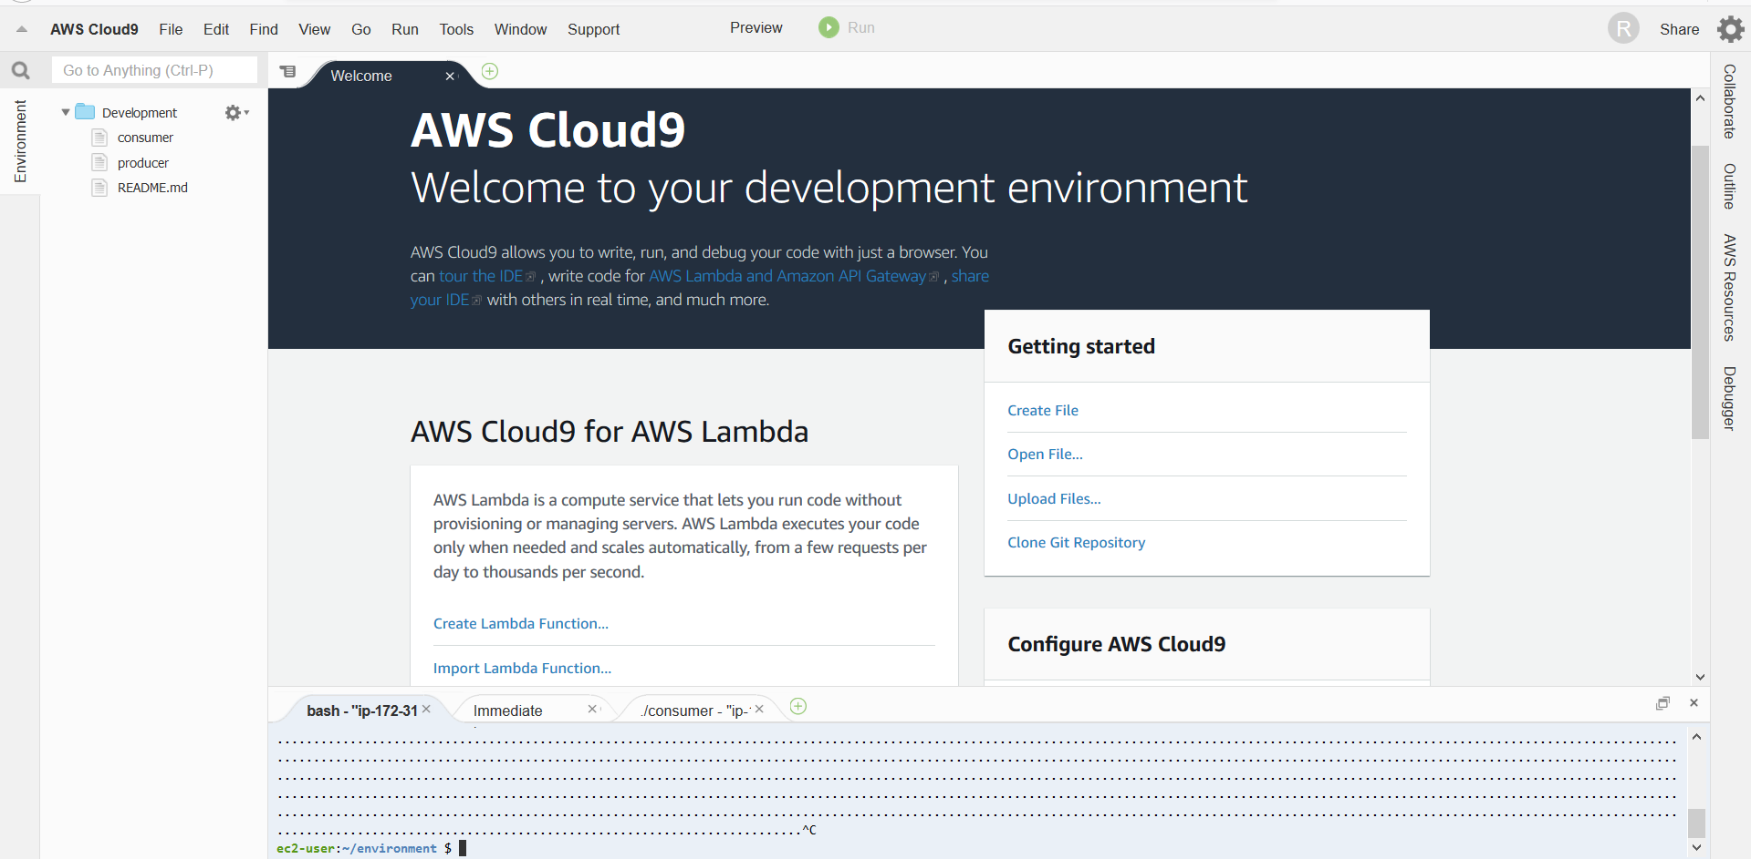

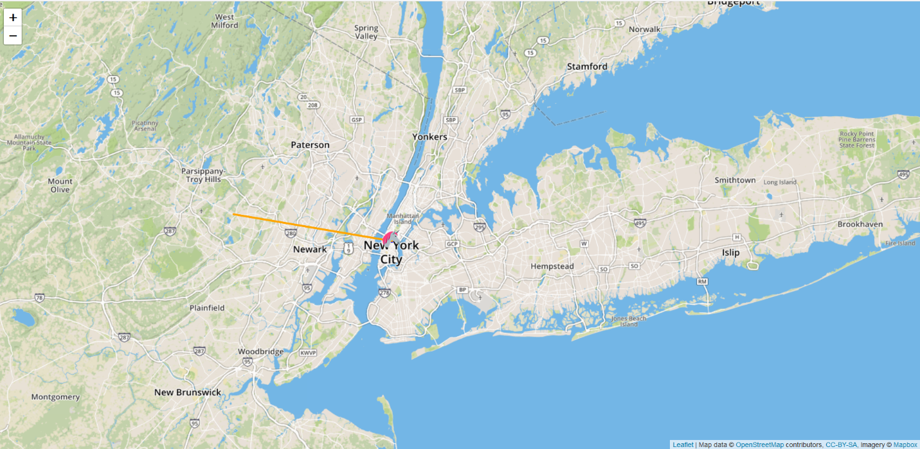

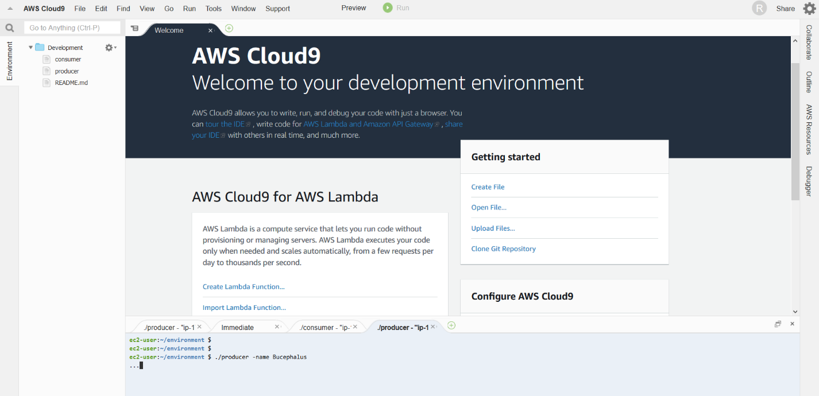

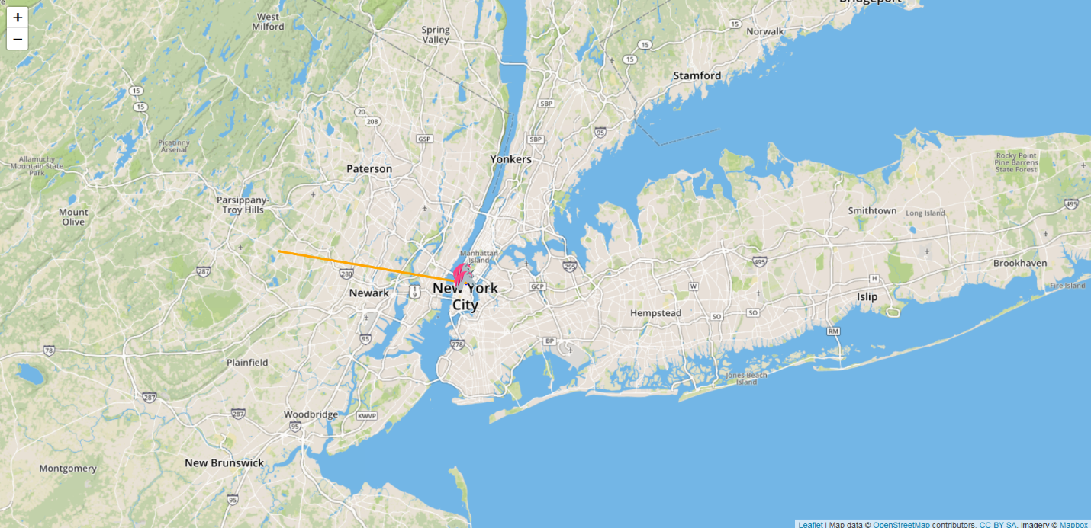

**Module 2: Aggregate data**

We will create an Amazon Kinesis Data Analytics application to aggregate sensor data from the unicorn fleet in real-time. The application will read from the Amazon Kinesis stream, calculate the total distance traveled, and minimum and maximum health and magic points for each unicorn currently on a Wild Ryde and output these aggregated statistics to an Amazon Kinesis stream every minute.

Create a data stream in Amazon Kinesis Service by naming it and keeping sharding minimum to 1 for testing and evaluation basis. Once done, create a Kinesis Data Analytics application which reads the stream and emits a JSON value based on the attributes of the stream. Make sure that producer in Amazon Cloud9 application is streaming and generating data. Link the data analytics application with the Kinesis stream created in Module 1 and make sure that the schema discovered is valid. Run the SQL query so that the stream is being captured and stored as rows. Connect it with the destination.

We need to read the messages form the stream. Make sure that in Amazon Cloud9 environment, consumer is reading senor data. We can produce multiple producer which will lead to multiple unicorns and rows being captured.

Thus, we have created a Kinesis Data Analytics application that reads from the Kinesis stream of unicorn data and emits a summary row each minute.

Screenshots:

Create an Amazon Kinesis stream

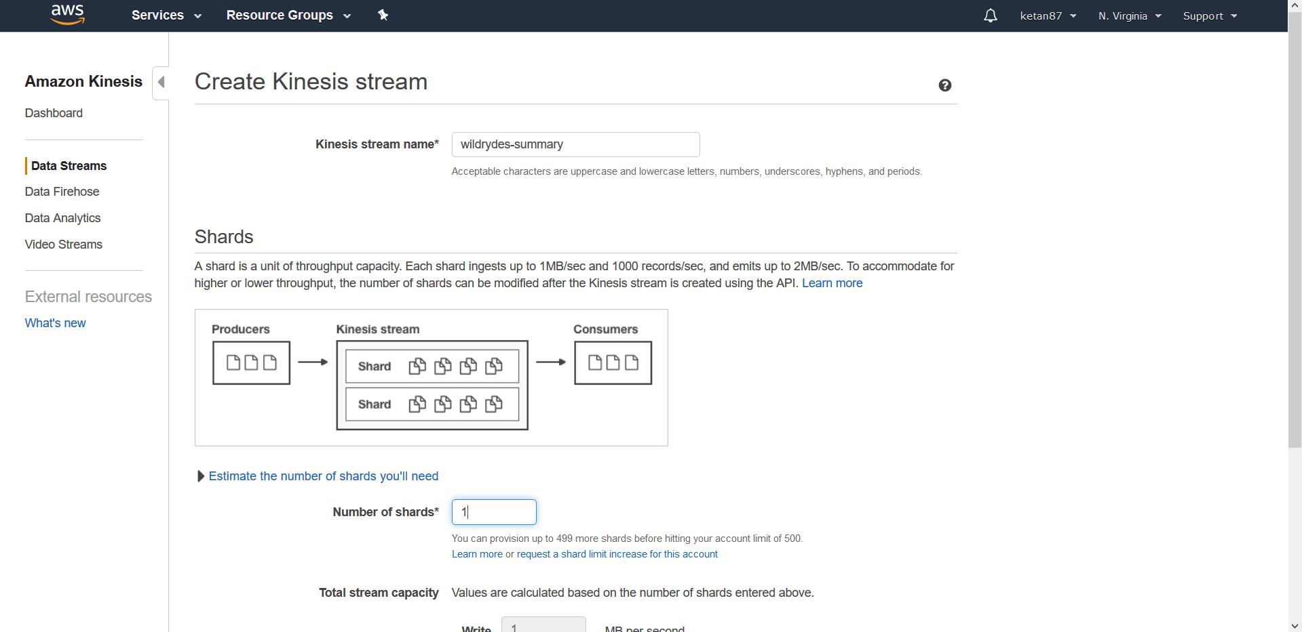

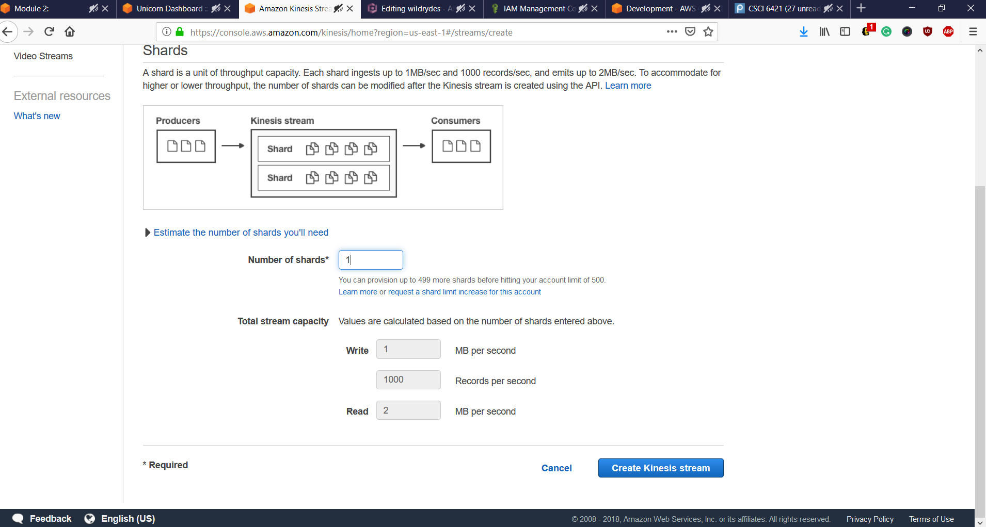

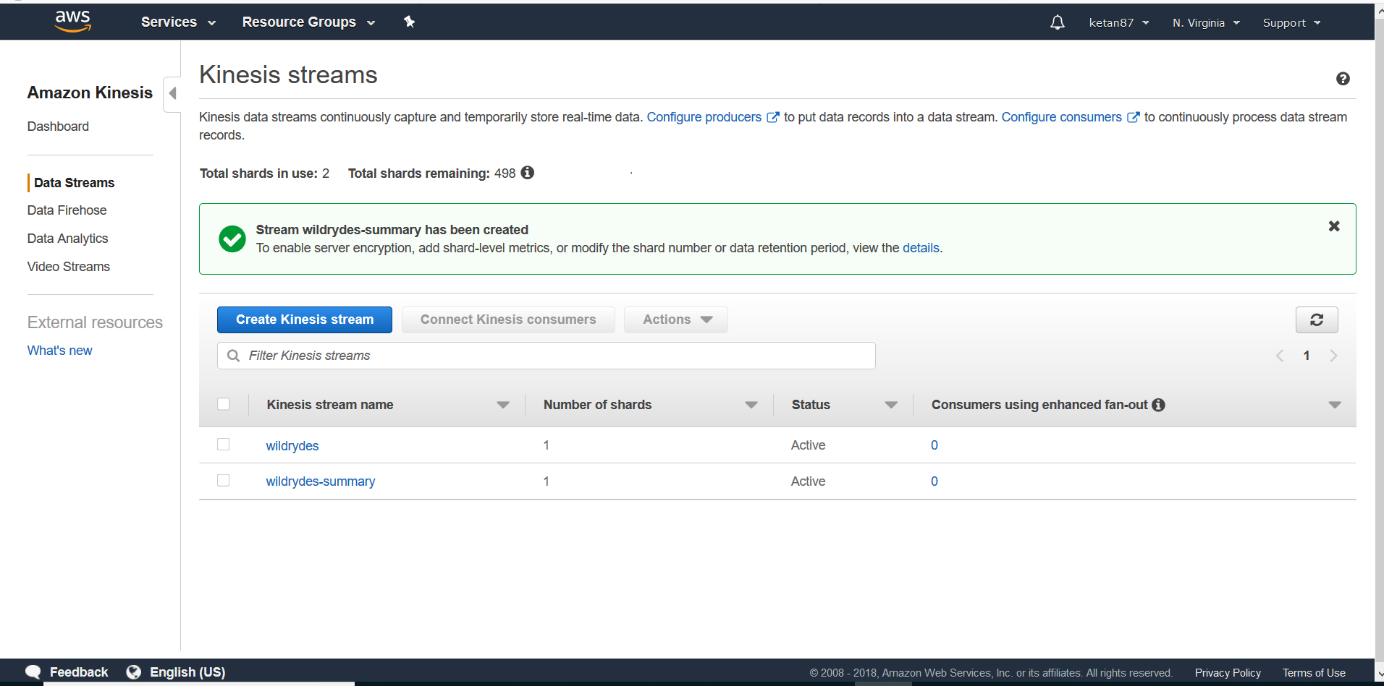

Create an Amazon Kinesis Data Analytics application

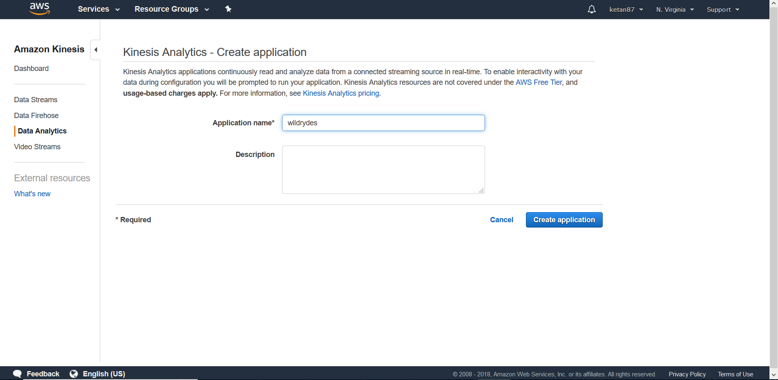

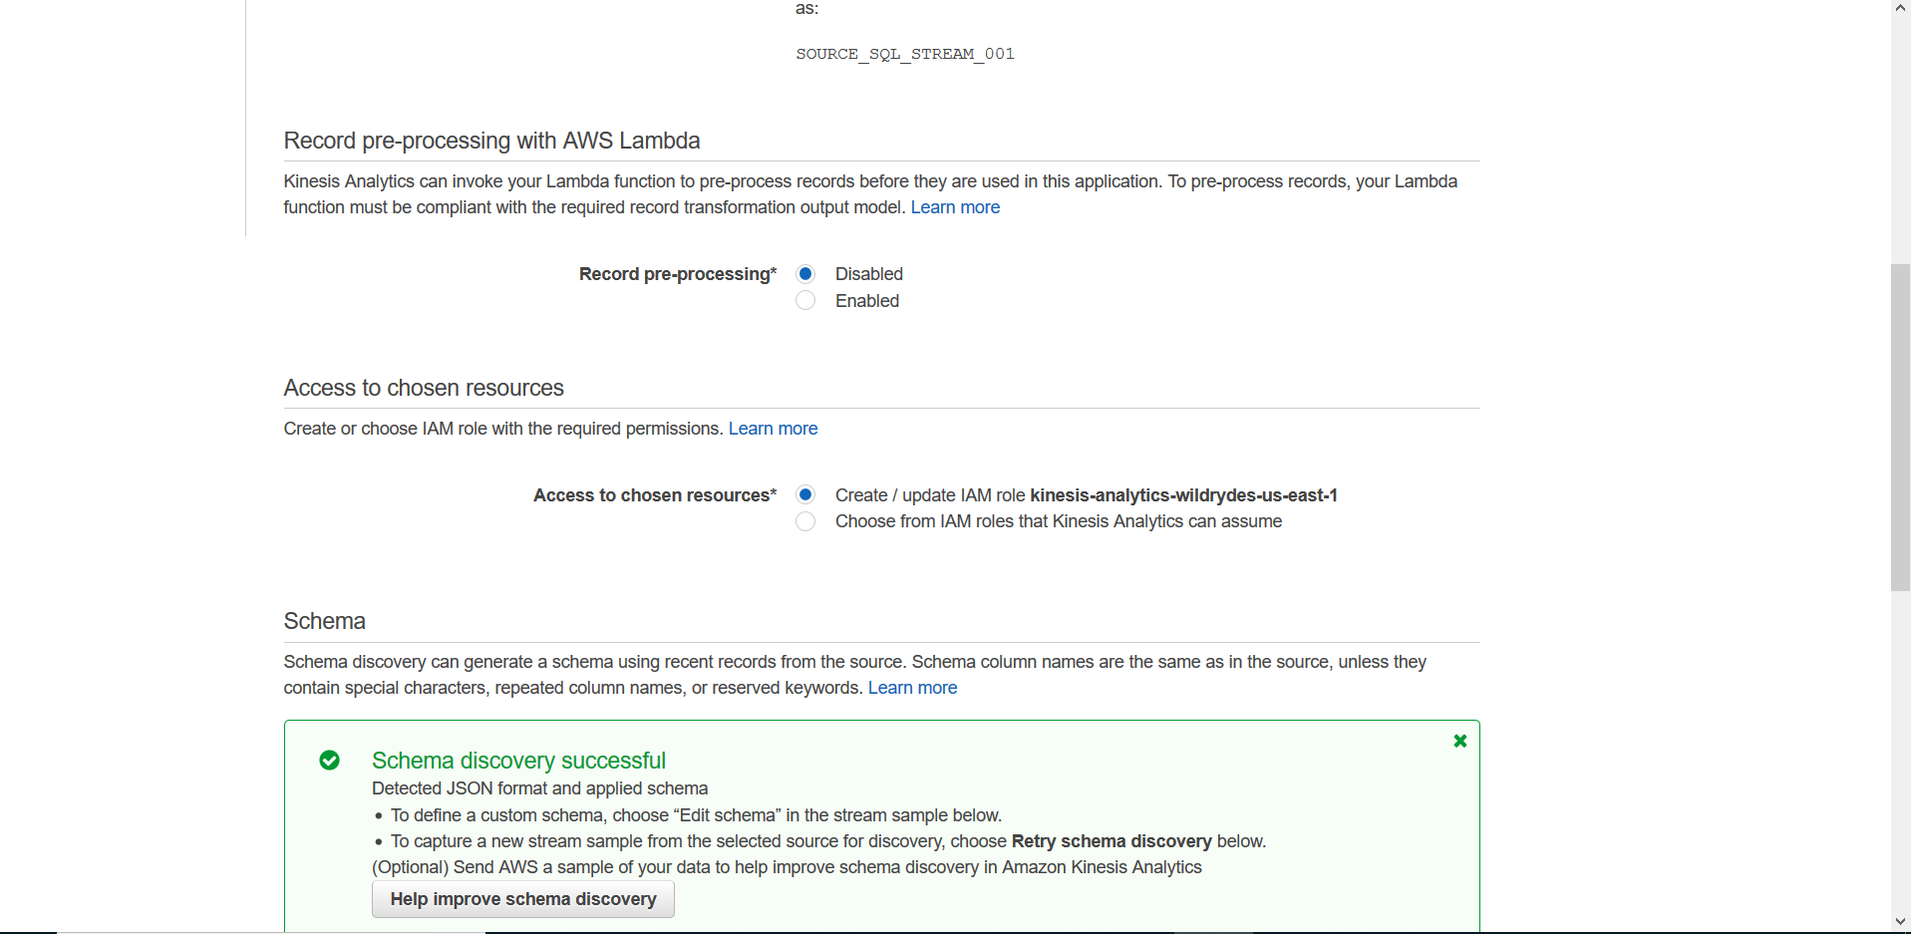

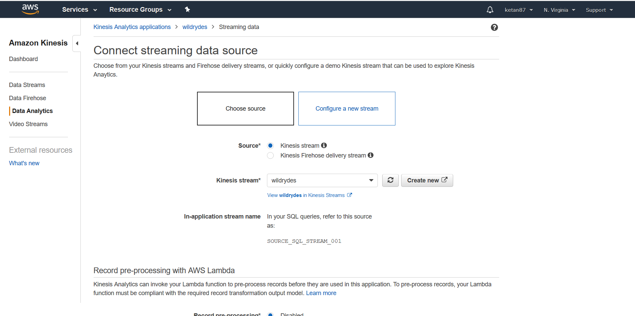

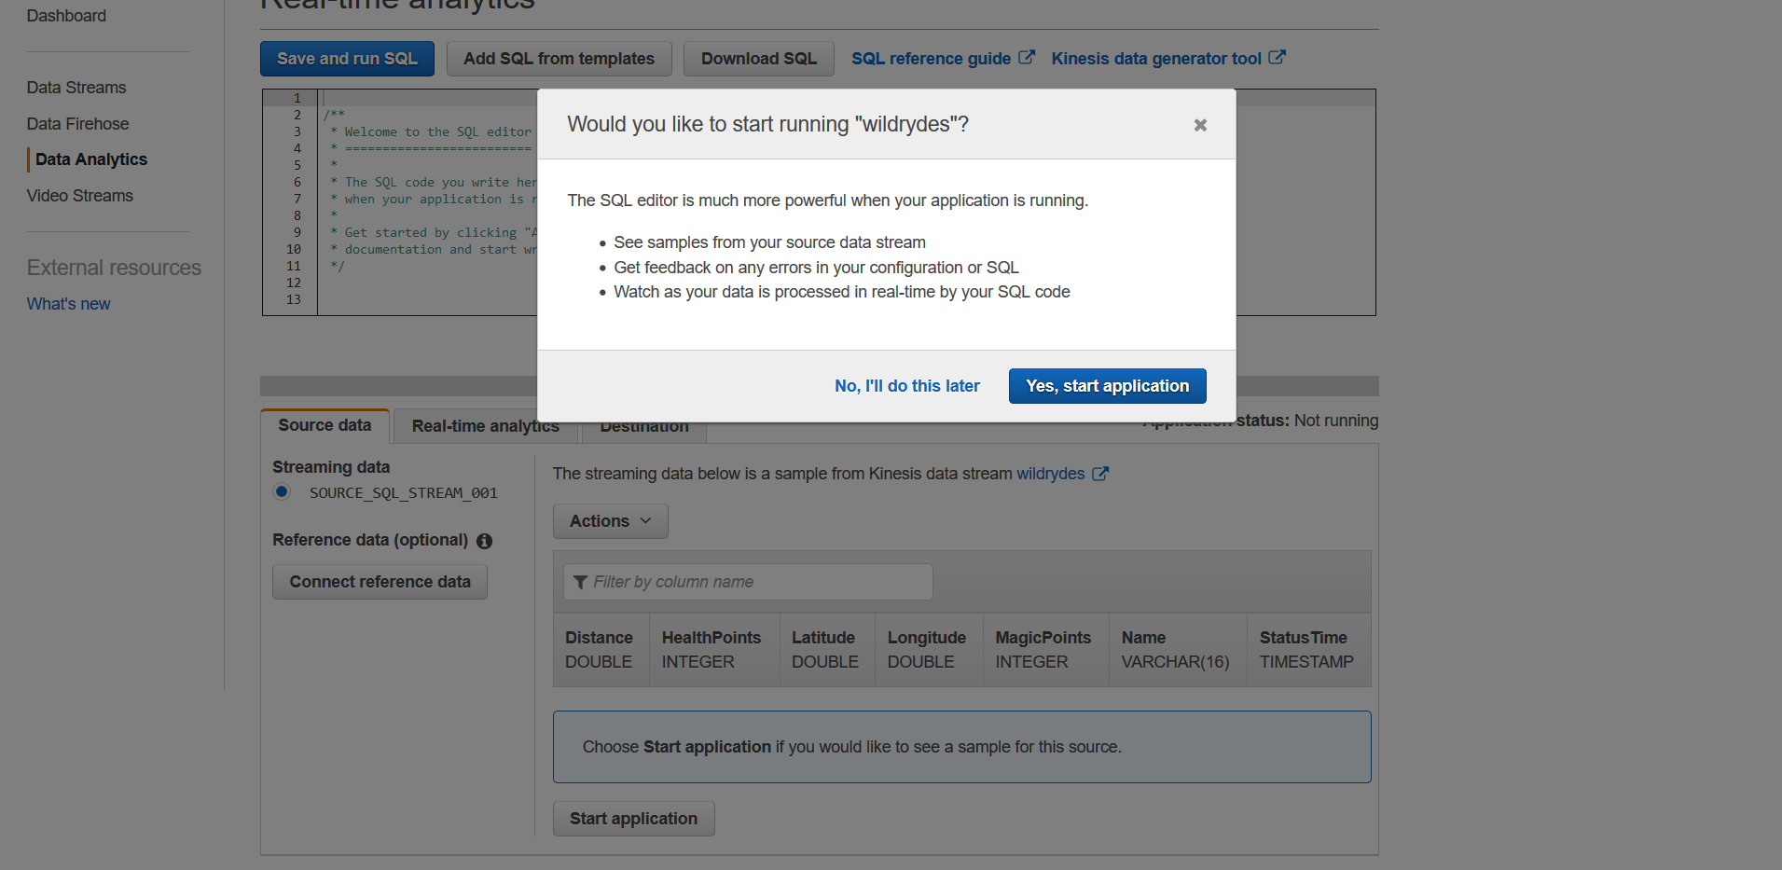

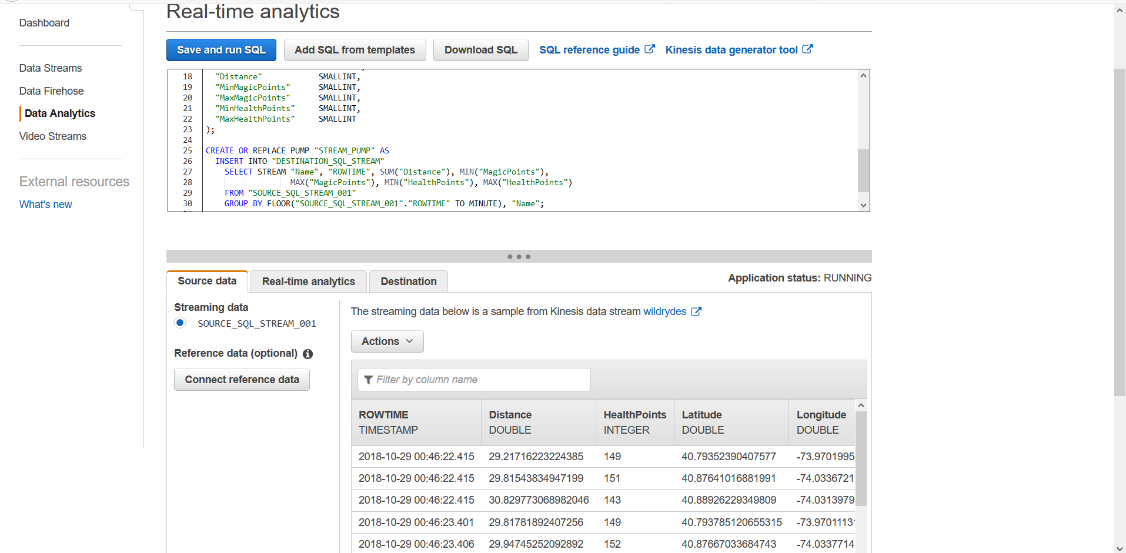

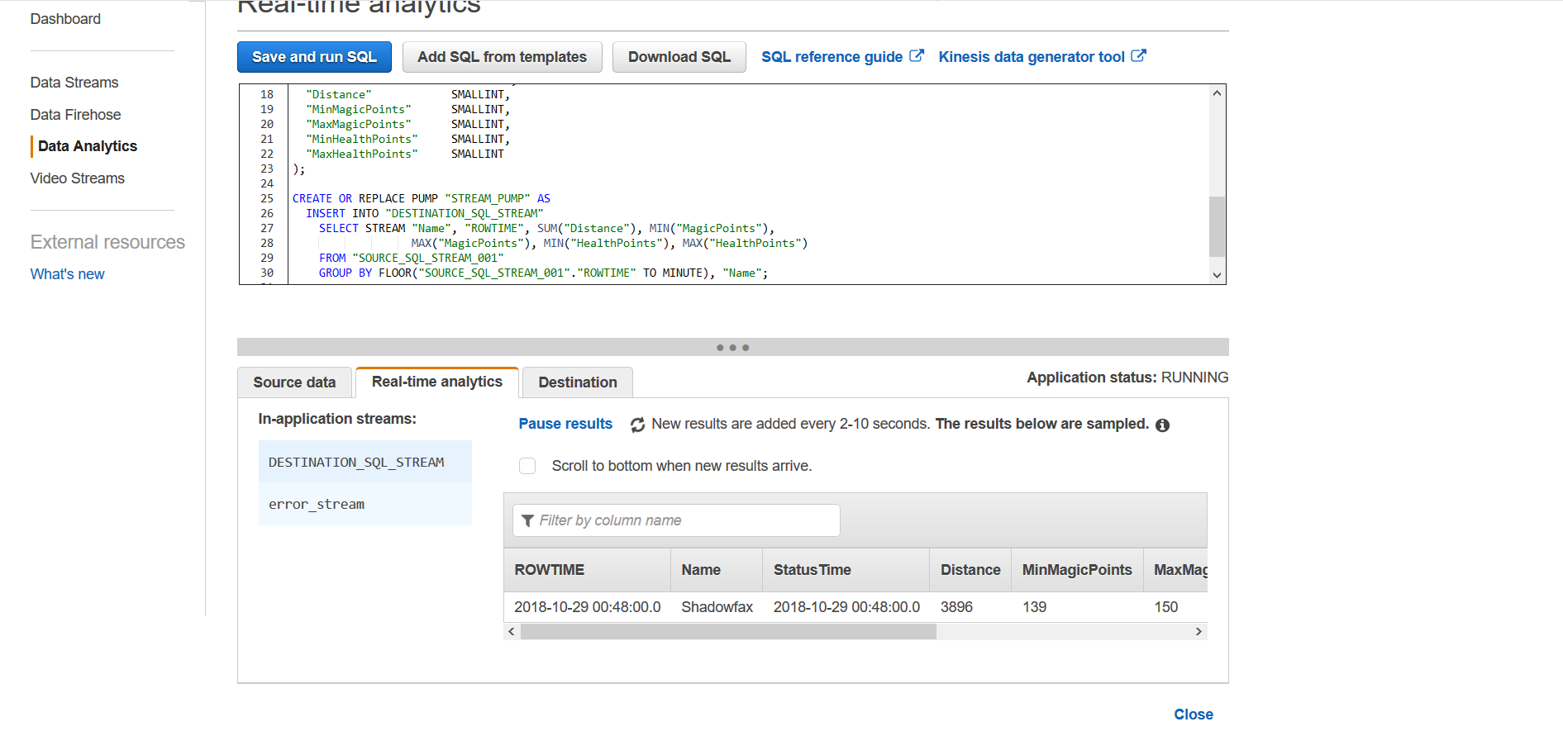

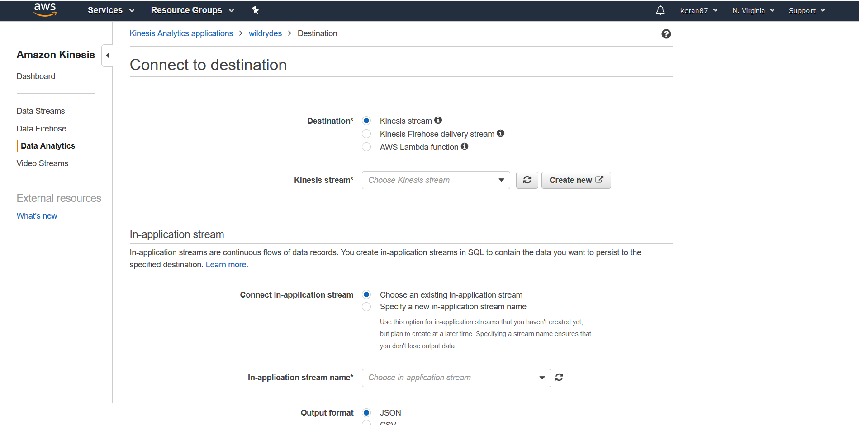

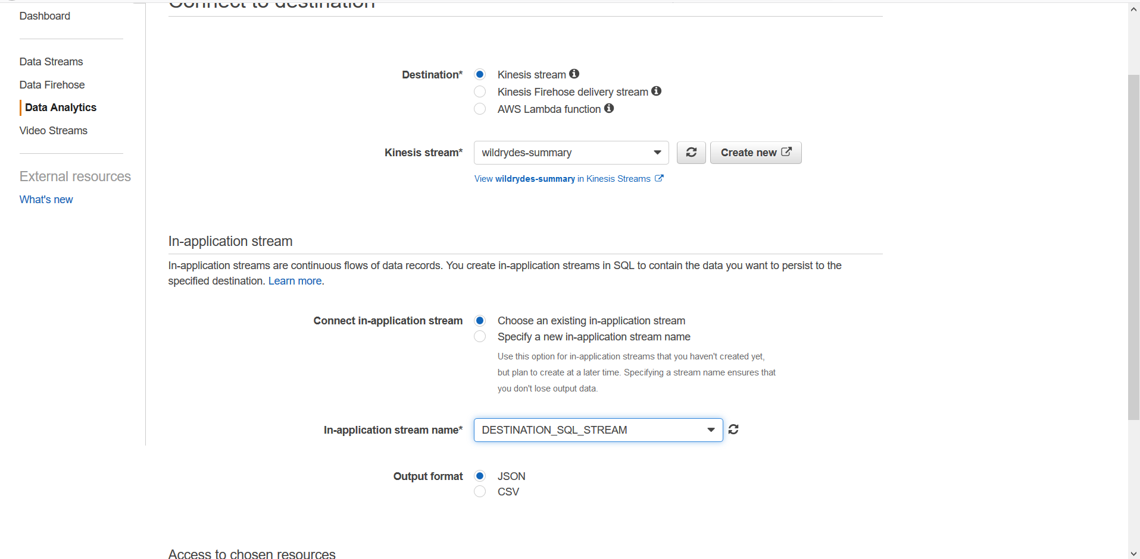

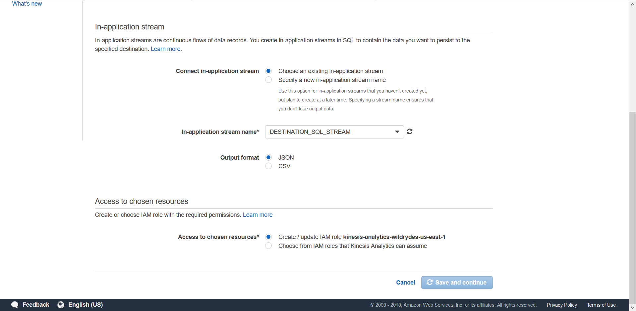

Read messages from the stream

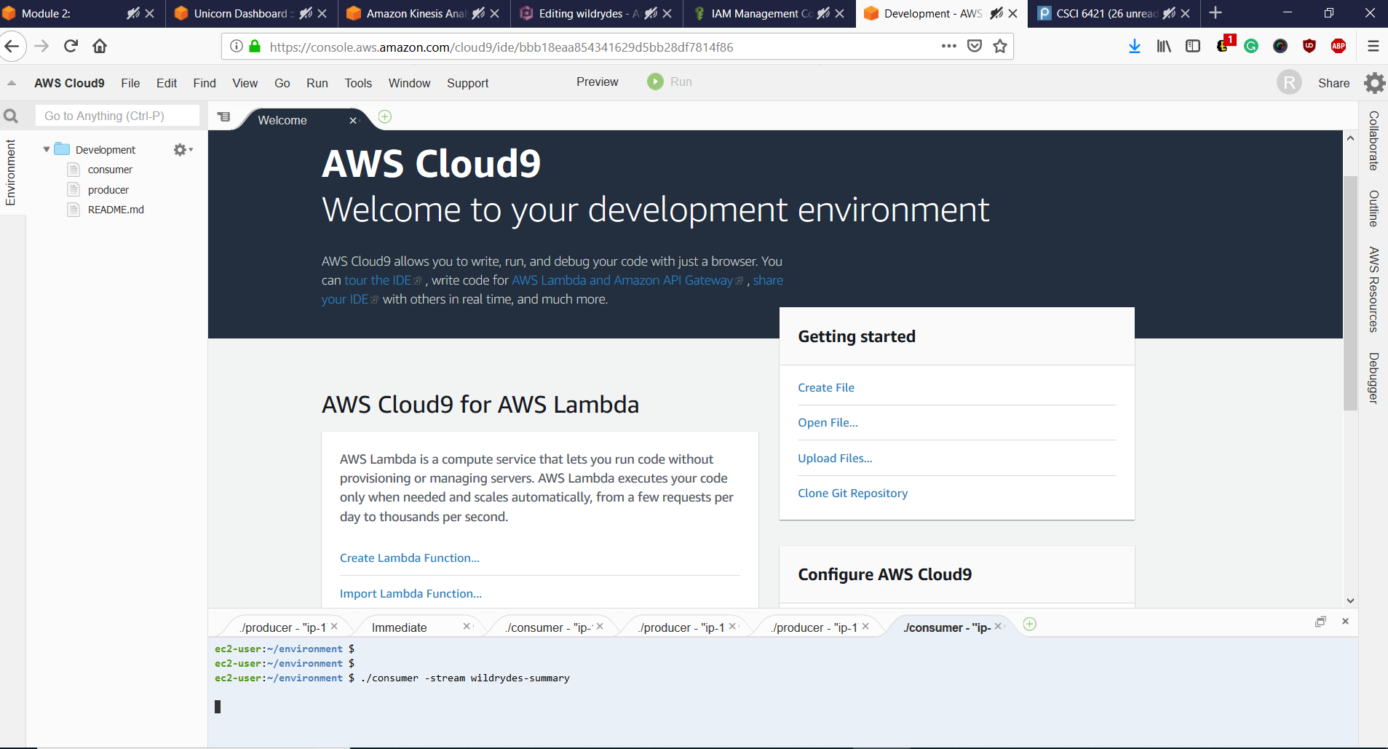

Experiment with the producer

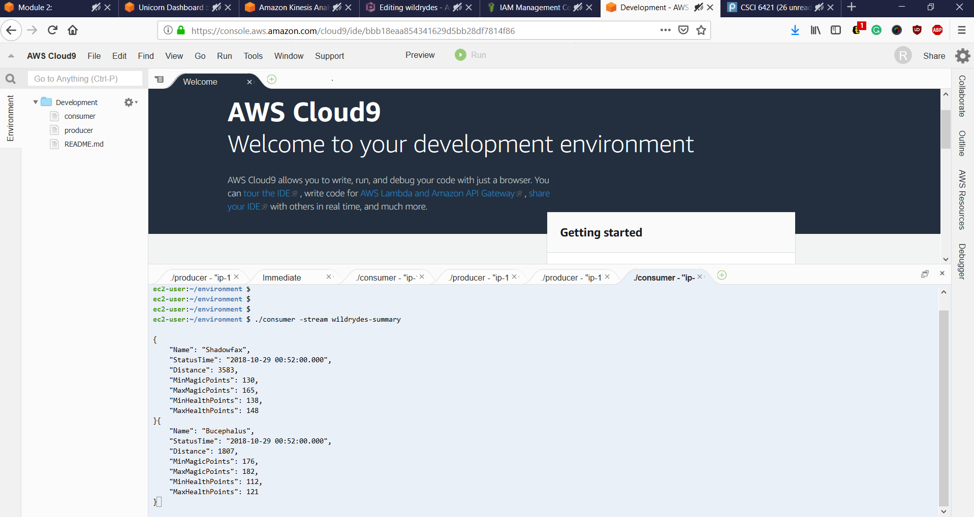

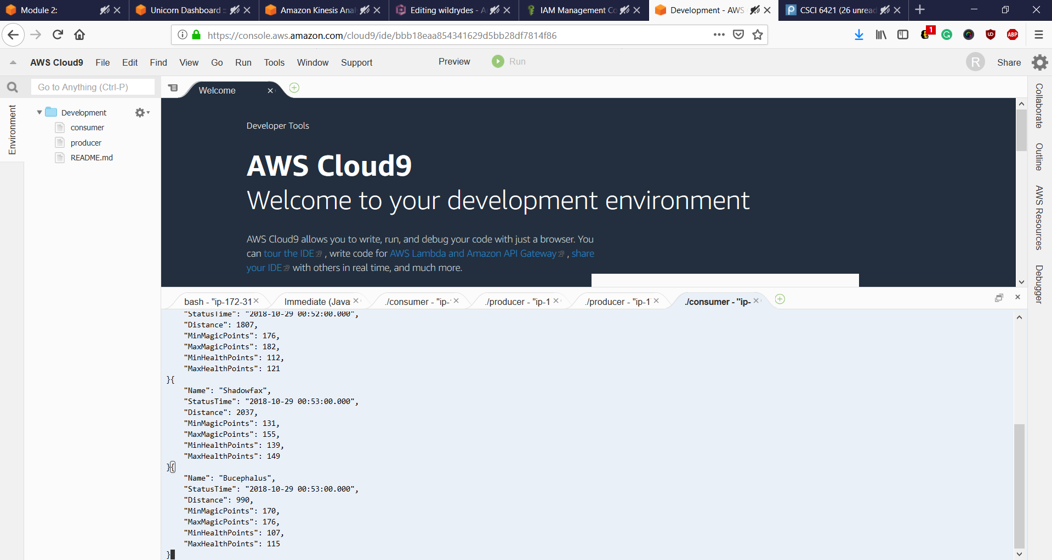

**Module 3: Process streaming data**

We use AWS Lambda to process data from the *wildrydes*Amazon Kinesis stream created earlier. We’ll create and configure a Lambda function to read from the stream and write records to an Amazon DynamoDB table as they arrive.

Create an Amazon DynamoDB table with a String as Sort Key and another string as Partion Key. Make a note of the ARN end point of the DynamoDB table created.

Create an IAM Role so that Amazon Lambda can have read access to Amazon Kinesis created earlier and log into Amaozn Cloudwatch Logs. Create a Policy in Amazon IAM to have BatchWriteItem to the DynamoDB of the resources created earlier. Once created, create a Role under Amazon Lambda service with the above policy and AWSLambdaKinesisExecutionRole policy attached to it.

Once the Role is created with appropriate access, create a Lambda function that will be triggered whenever new record is available in the Kinesis stream created earlier. Create Nodejs version 6.10 with the IAM role created earlier. Insert the JS script file tracks the Kinesis stream. Set Timeout as 1 minute, Batch size of 100 as per our stream and Enable the trigger.

Monitor the Lambda through Cloudwatch logs. Create a new Producer in Amazon Cloudwatch9 environment to monitor it through logs.

We can observe that new rows are being added in the DynamoDB table. You can query the table for appropriate requirement.

Thus, we have created a Lambda function that reads from the Kinesis stream of summary unicorn data and saves each row to DynamoDB.

Screenshots:

Create an Amazon DynamoDB tables

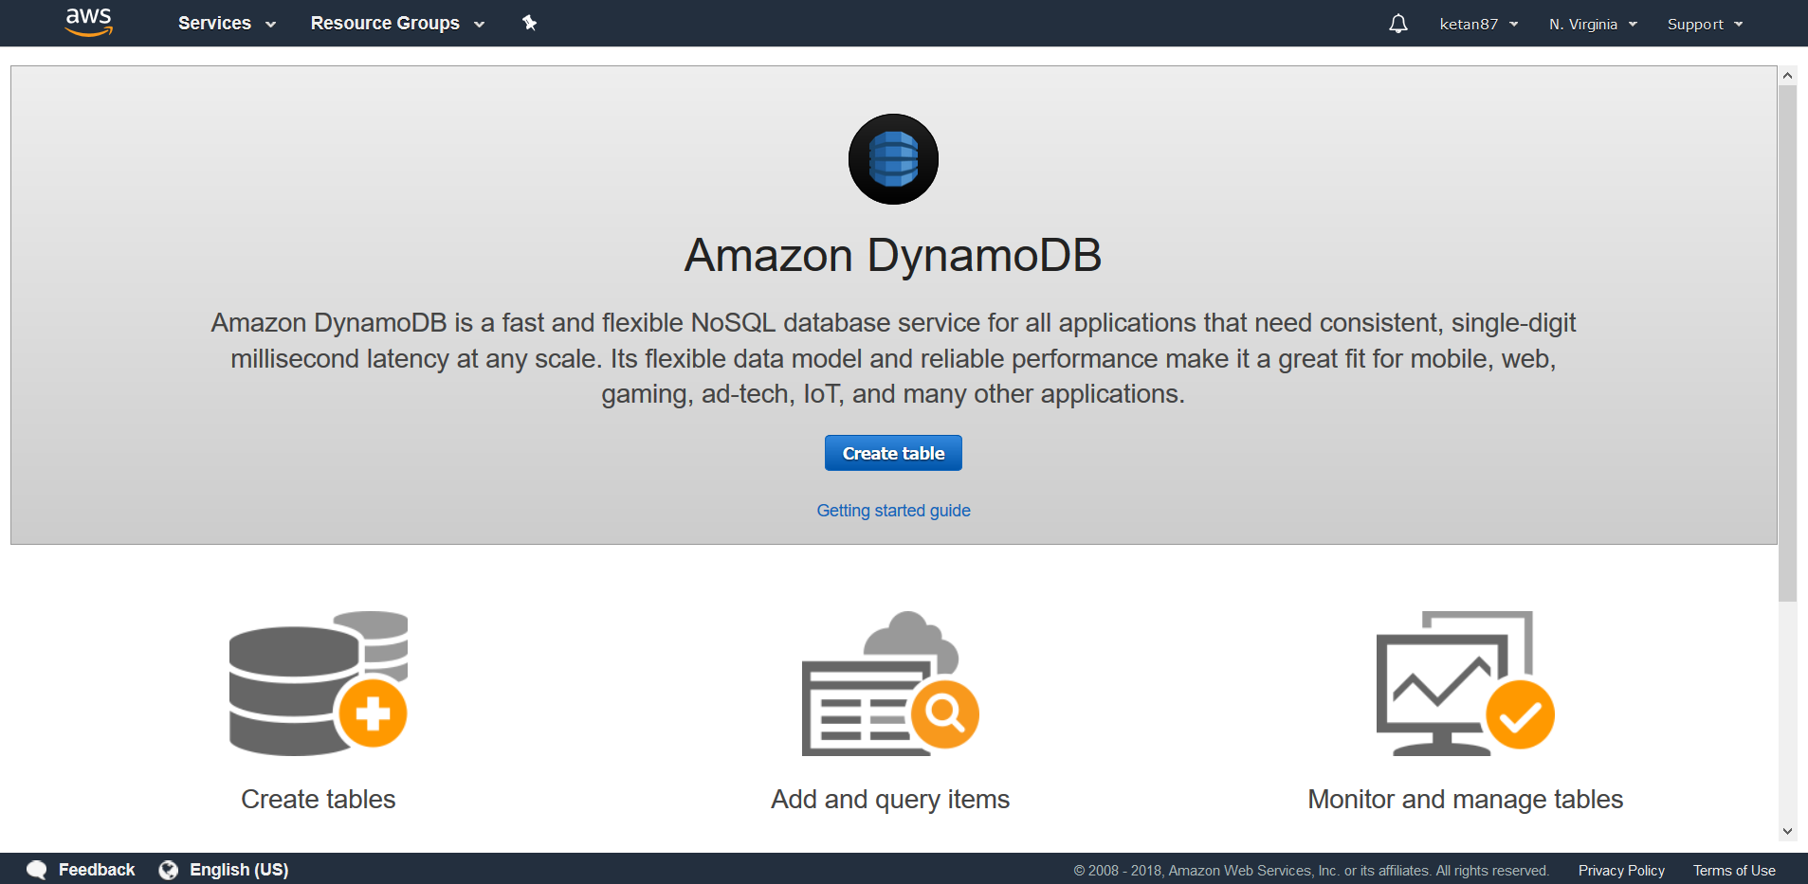

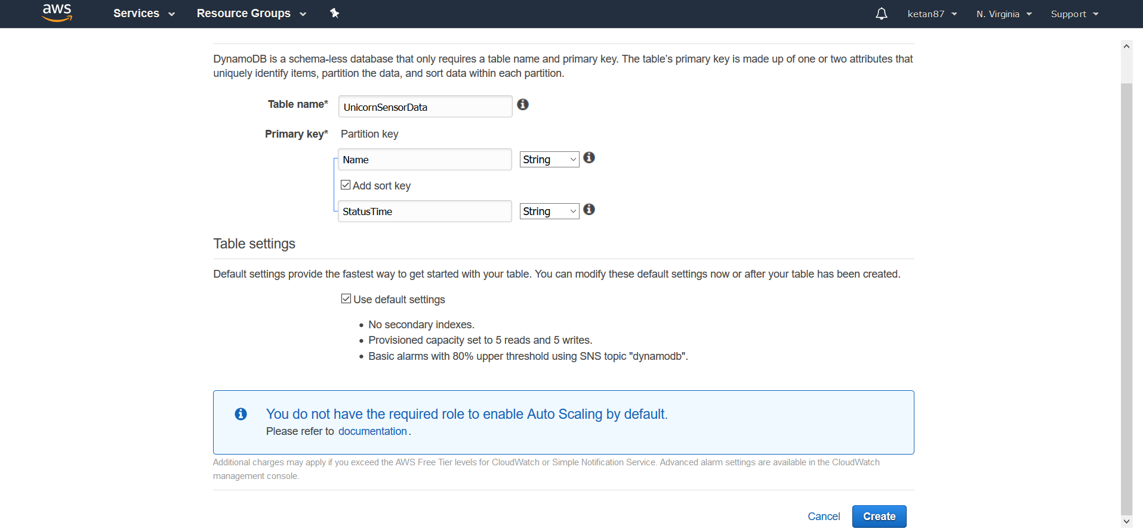

Create an IAM role for your Lambda function

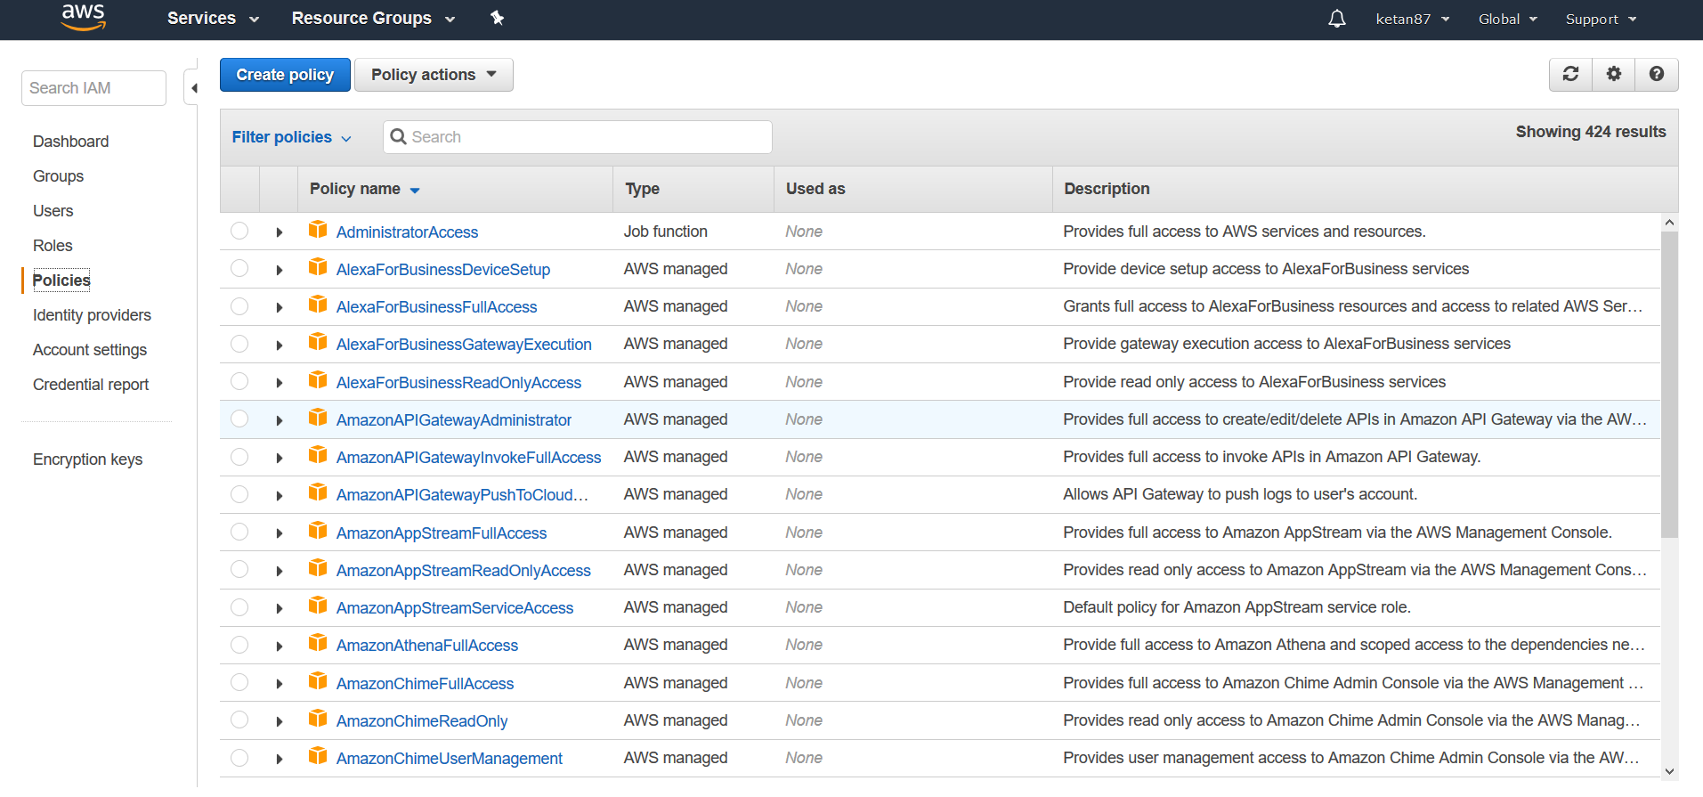

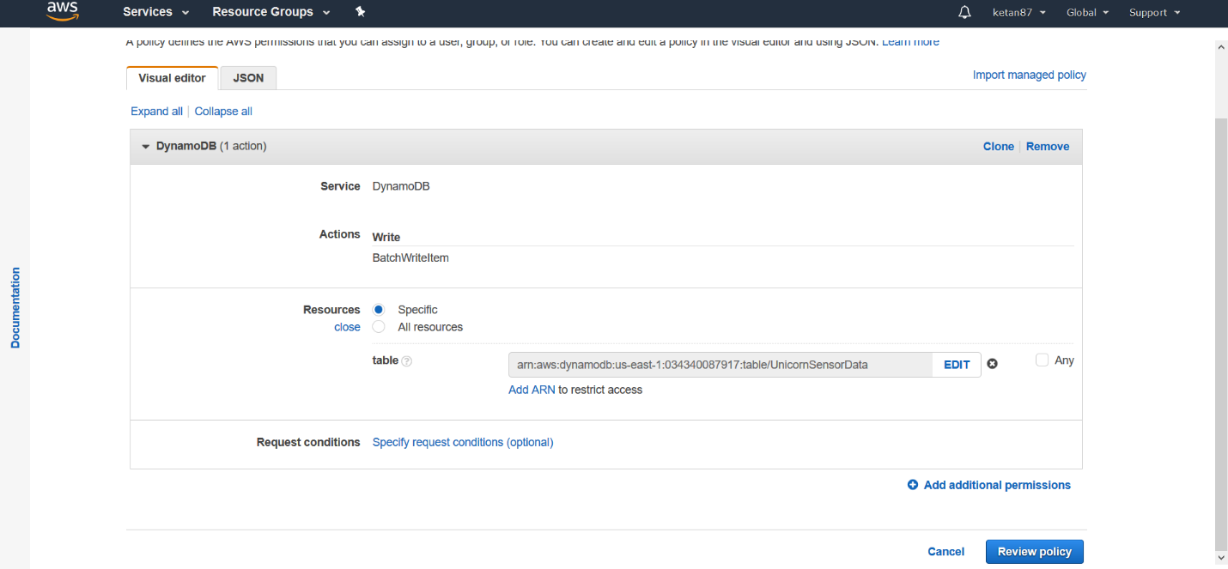

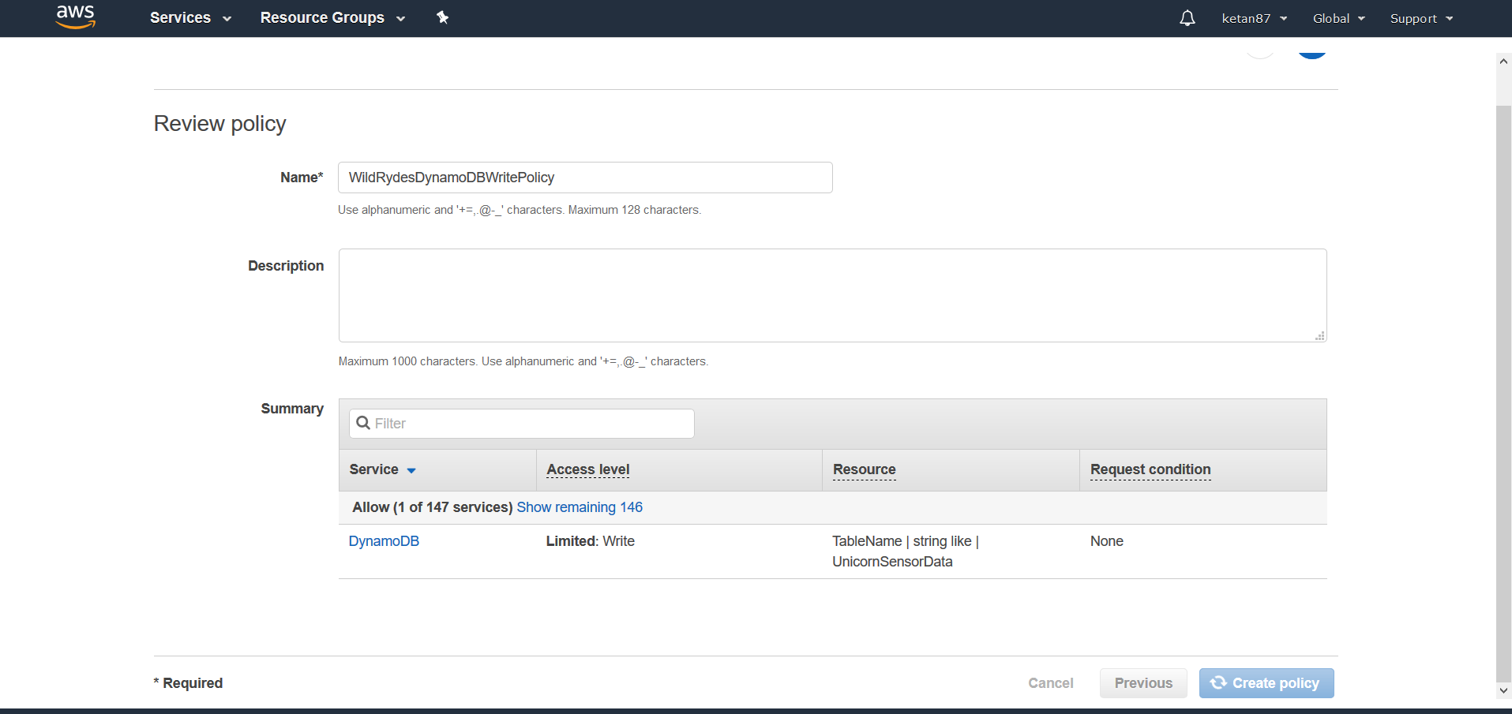

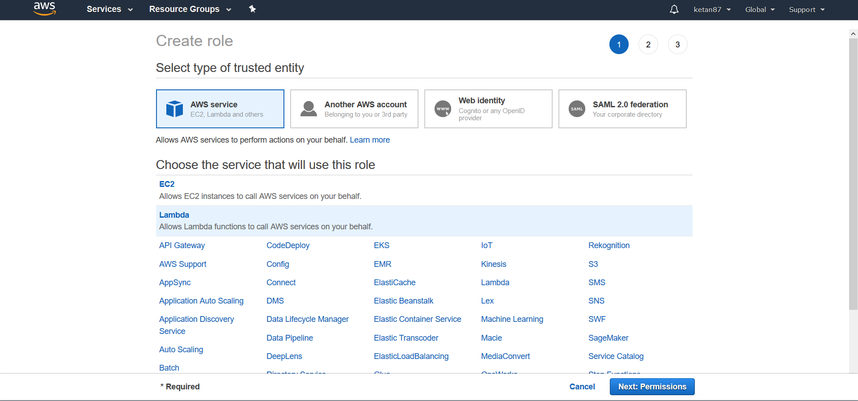

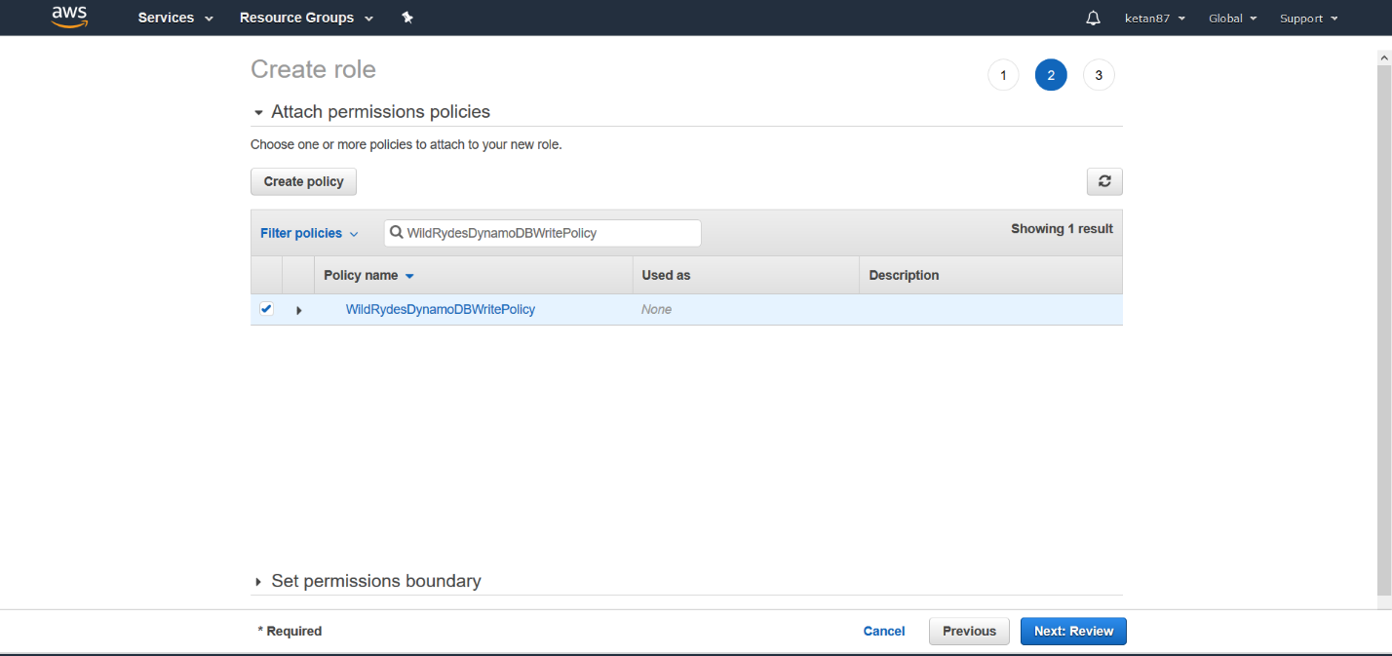

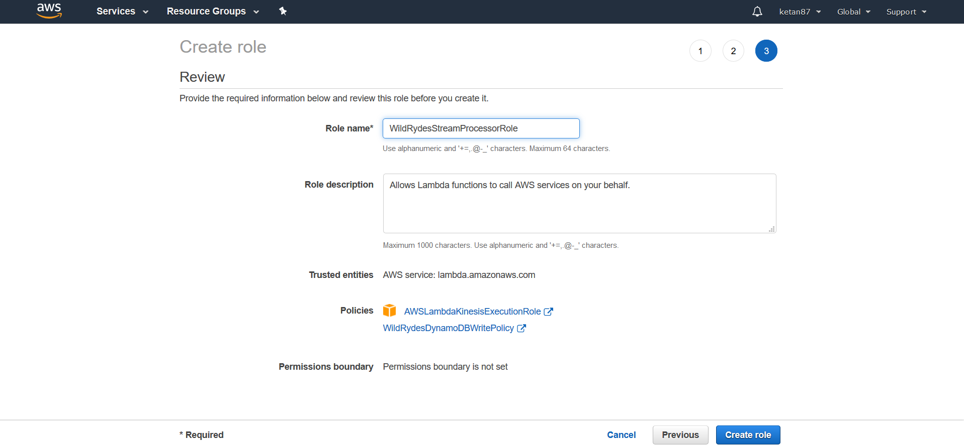

Create a Lambda function to process the stream

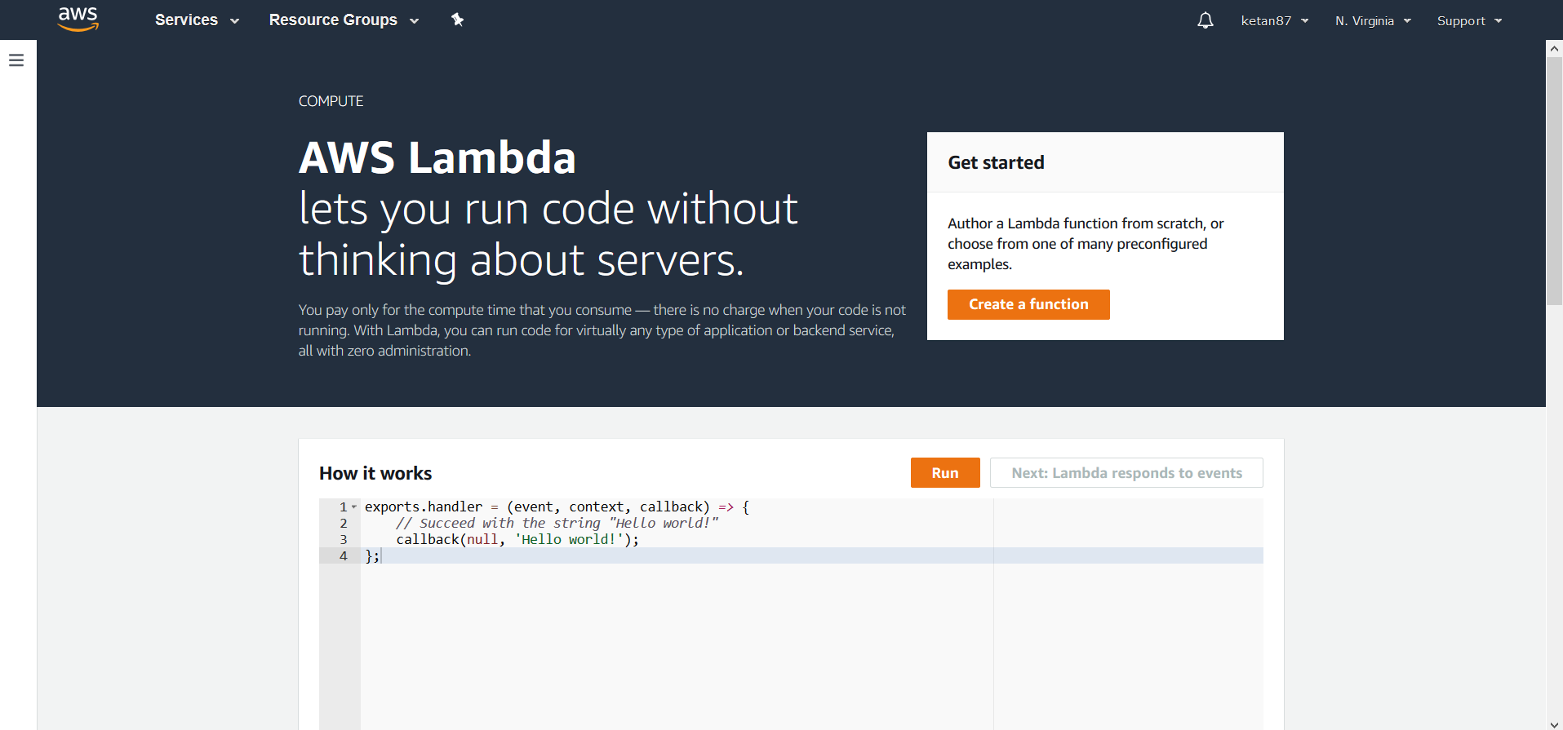

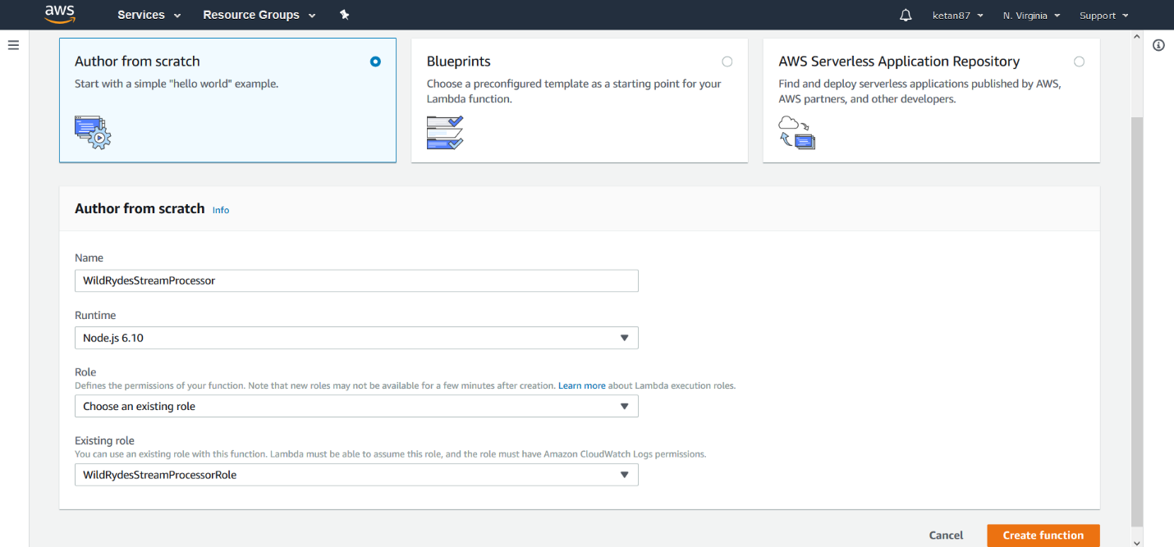

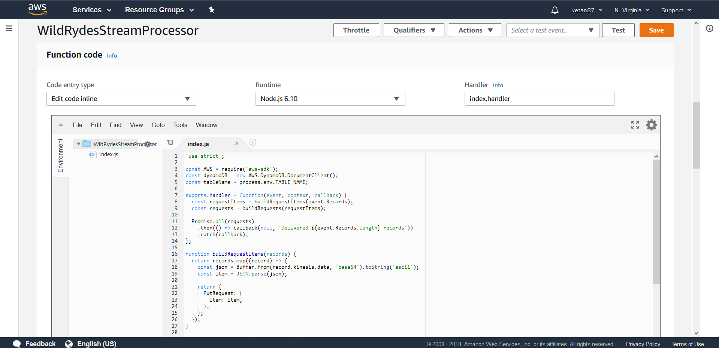

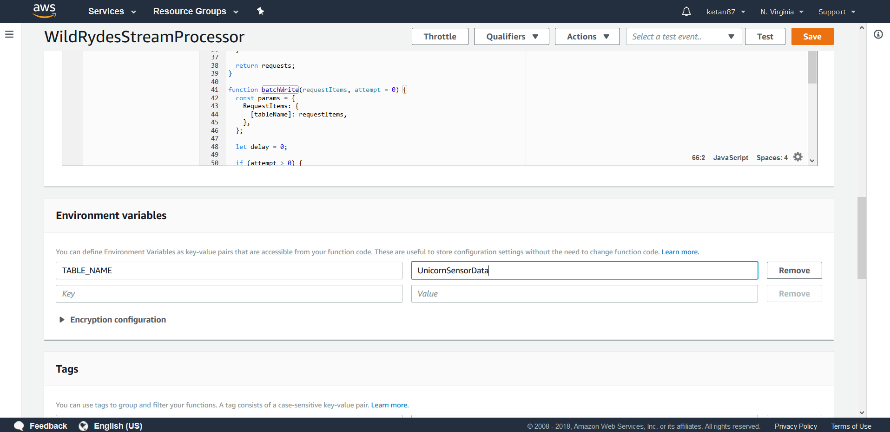

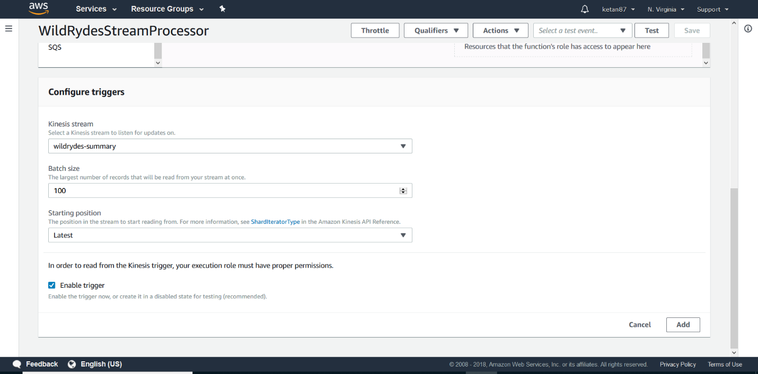

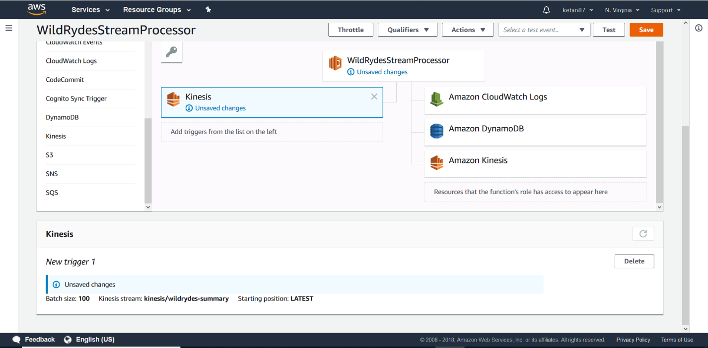

Monitor the Lambda function

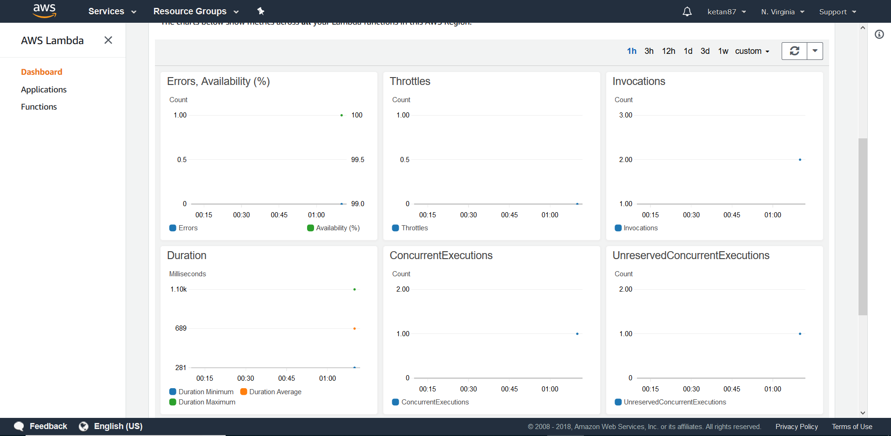

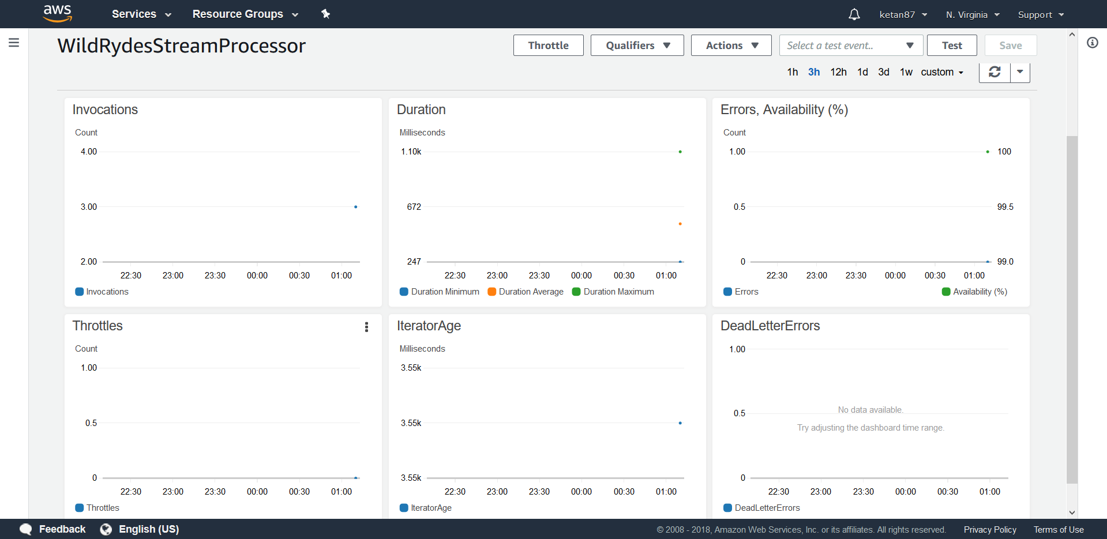

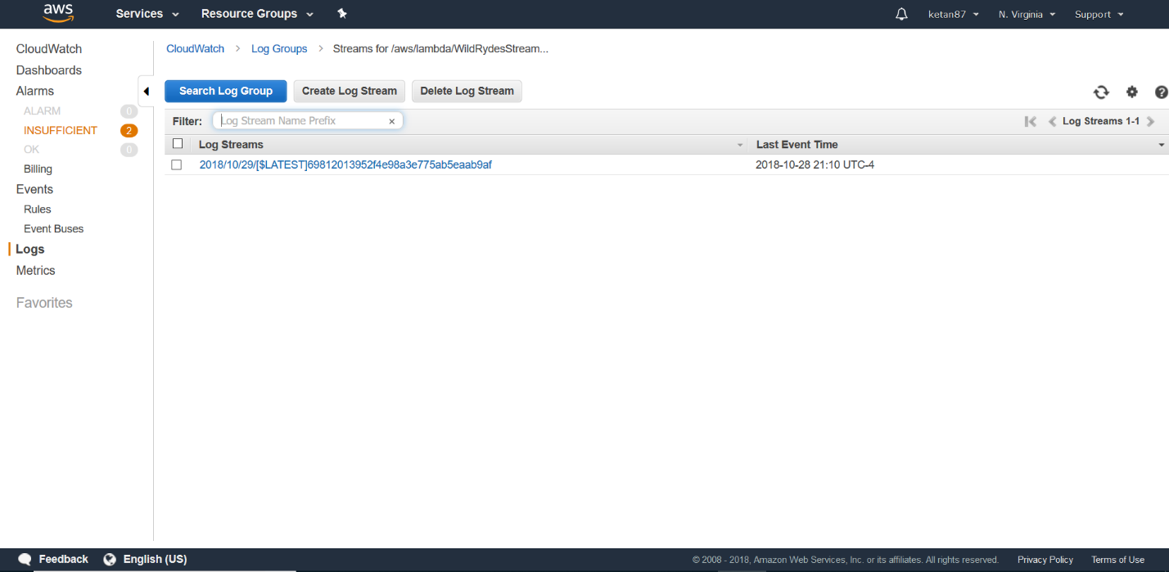

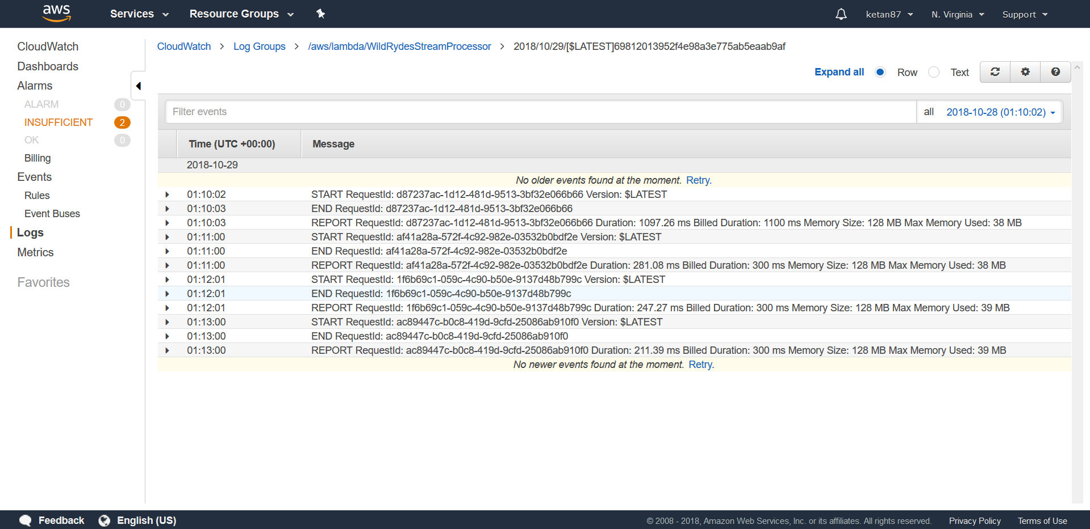

Query the DynamoDB table

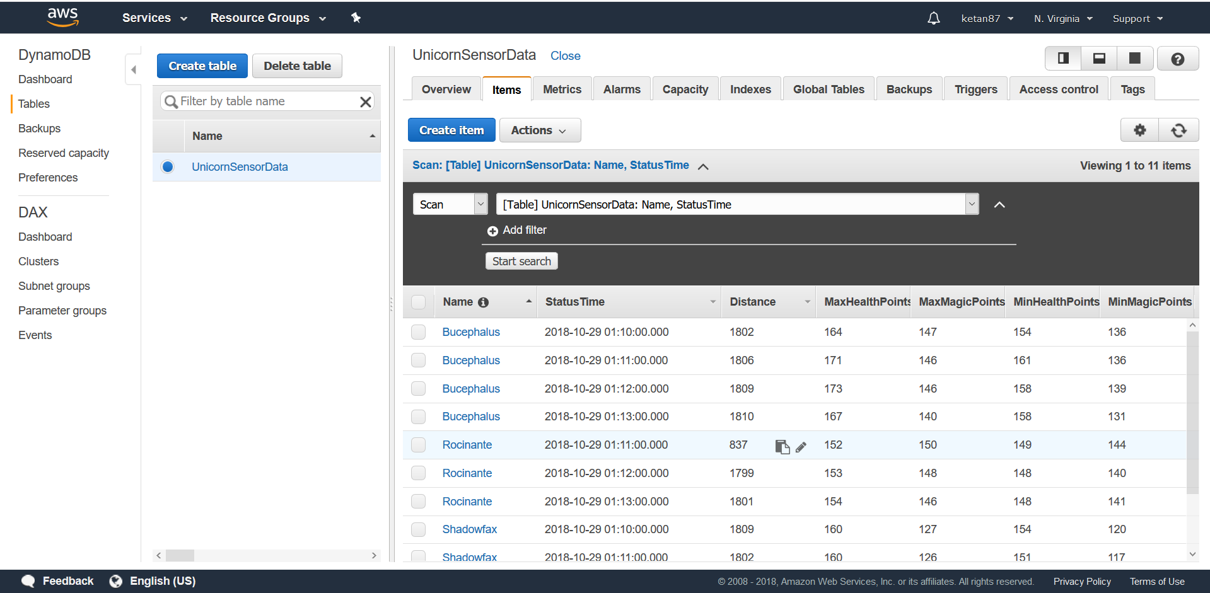

**Module 4: Store & query Data**

We need to create an Amazon Kinesis Data Firehose to deliver data from the Amazon Kinesis stream to Amazon Simple Storage Service (Amazon S3) in batches. Then Amazon Athena will run queries against our raw data in place. To batch the data, we need to use Amazon Kinesis Data Firehose which will later be archived in Amazon S3.

For the Amazon Kinesis Data Firehose to archive the data in Amazon S3 bucket, we first need to create a Amazon S3 bucket. Then create an Amazon Kinesis Data Firehose delivery stream with the kinesis stream created earlier as the source stream and the S3 bucket created now as the destination bucket. Set Buffer interval as 60 deliveries per minutes which is set as the kinesis stream.

Once the Amazon Kinesis Data Firehose is created, data will be archived in Amazon S3 bucket. To query this raw data, we will use Amazon Athena service. Create an Amazon Athena Table by creating table through SQL query with S3 bucket located as the location.

The data will be stored in S3 bucket as per the year, month, day and hour accordingly in the folder. You can view the logs to view the output or download the raw data and view in text editor.

Now that raw data is stored in S3 bucket and Athena table ready, you can ad-hoc queries against the raw data in the Amazon S3 bucket via SQL query.

Thus, we have created a Kinesis Data Firehose deliery stream to deliver data from the Kinesis stream to an Amazon S3 bucket and using Athena, we ran queries against this data on S3.

Screenshots:

Create an Amazon S3 bucket

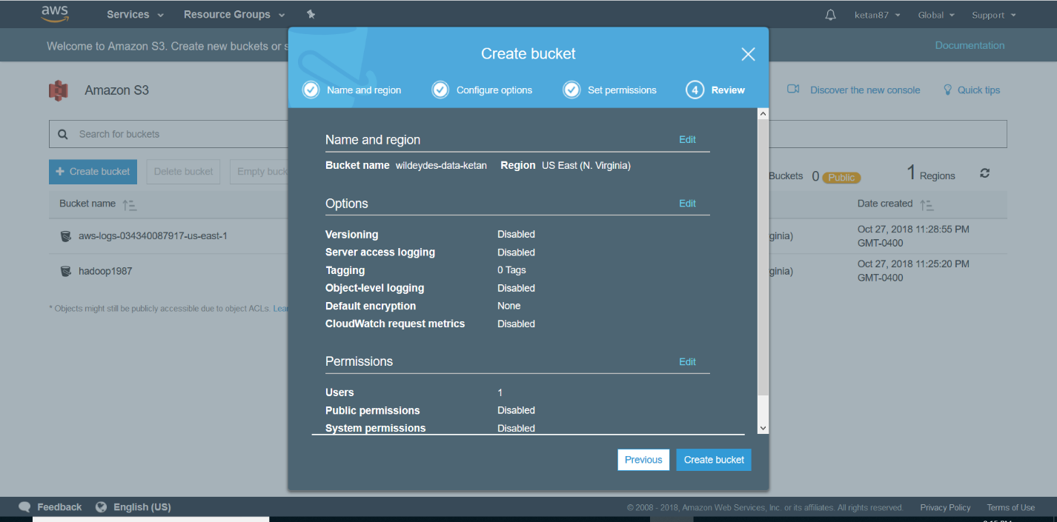

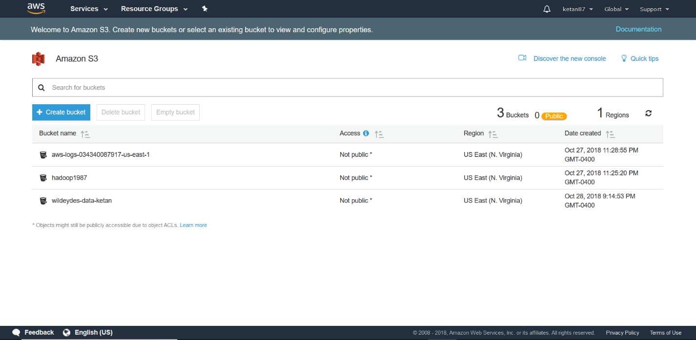

Create an Amazon Kinesis Data Firehose delivery stream

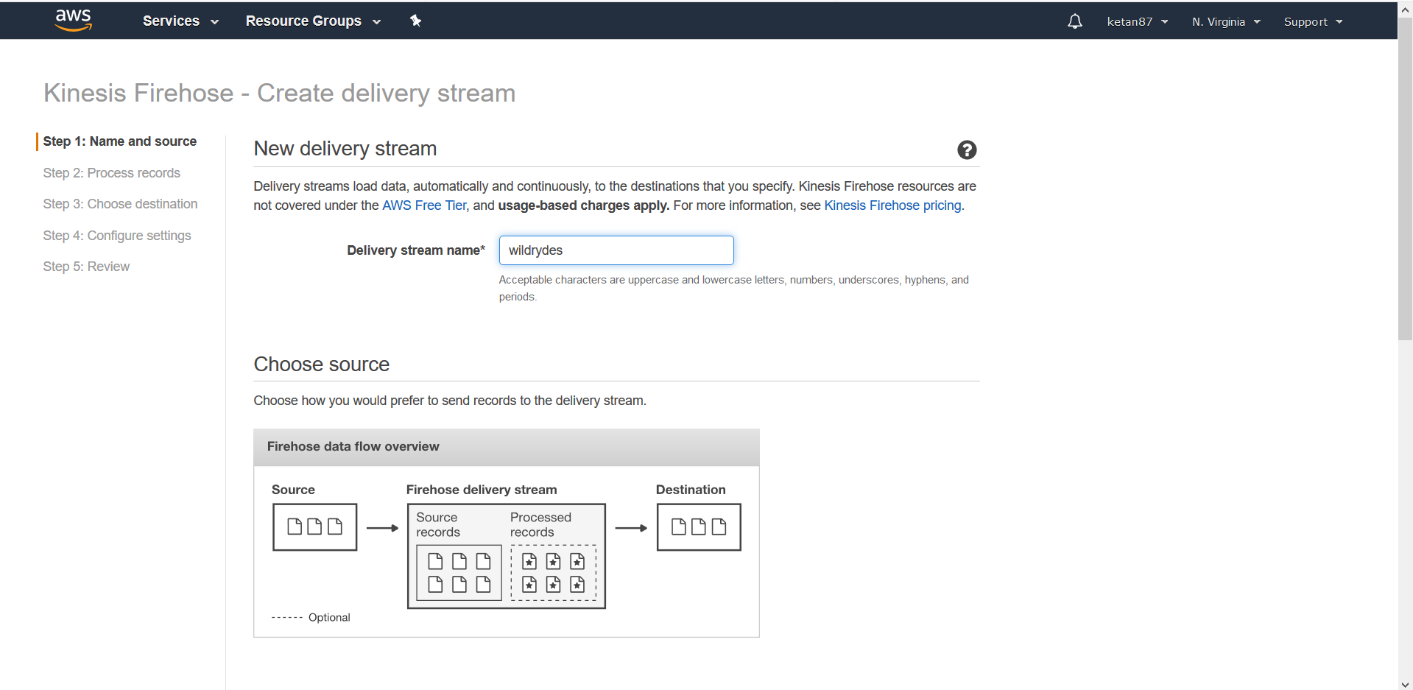

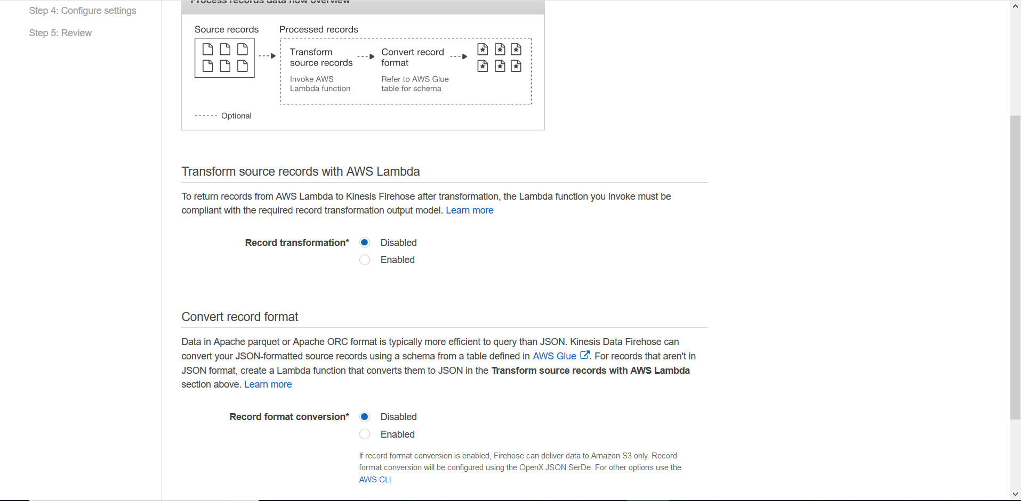

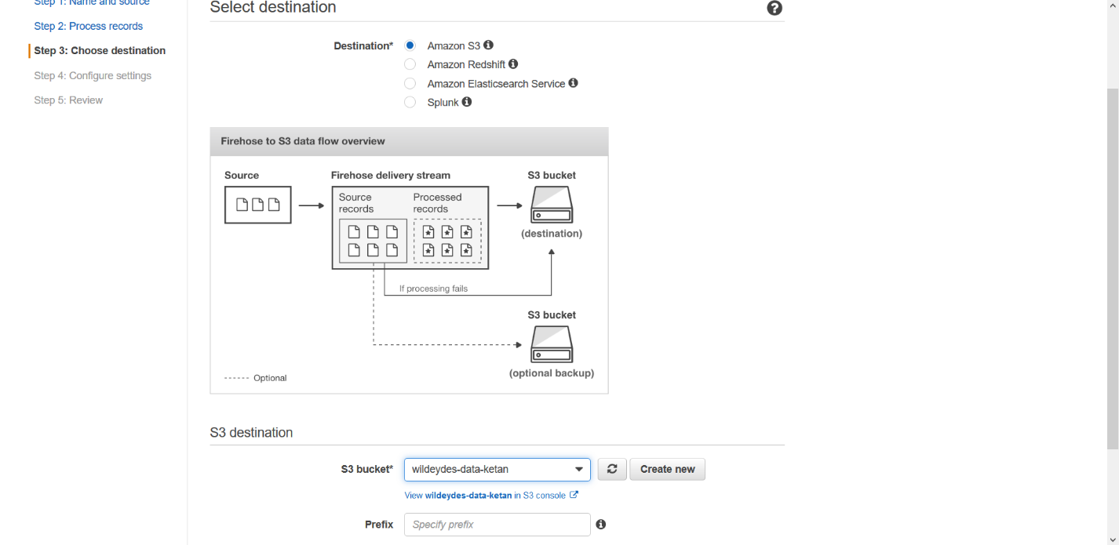

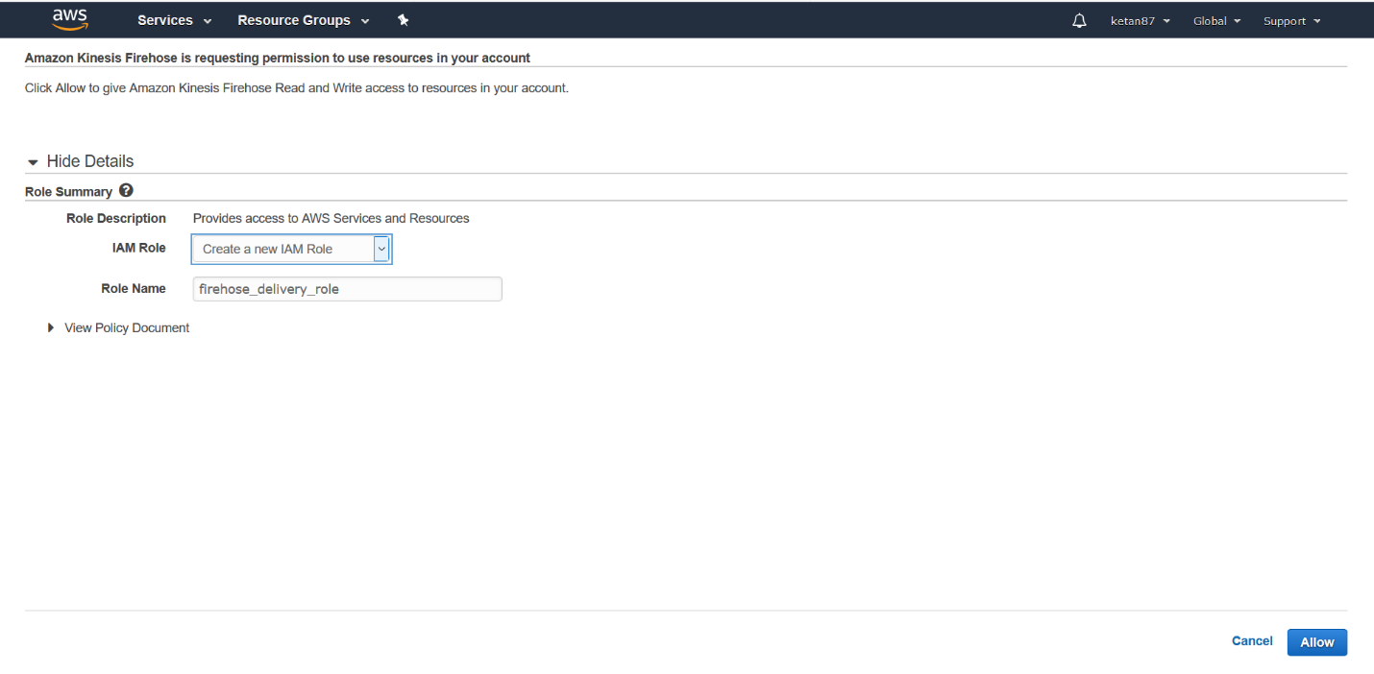

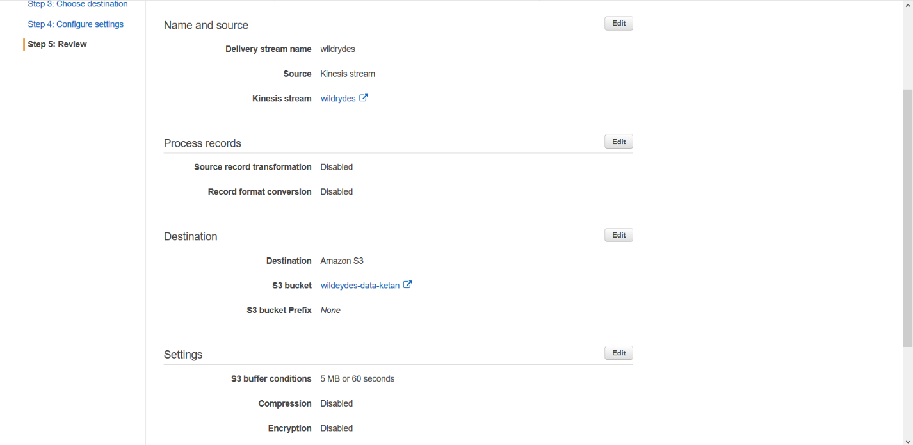

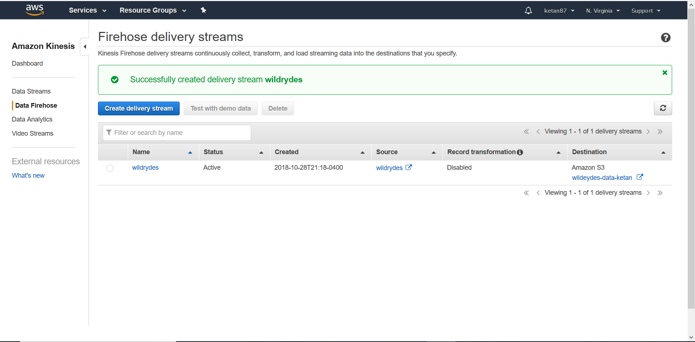

Create an Amazon Athena table

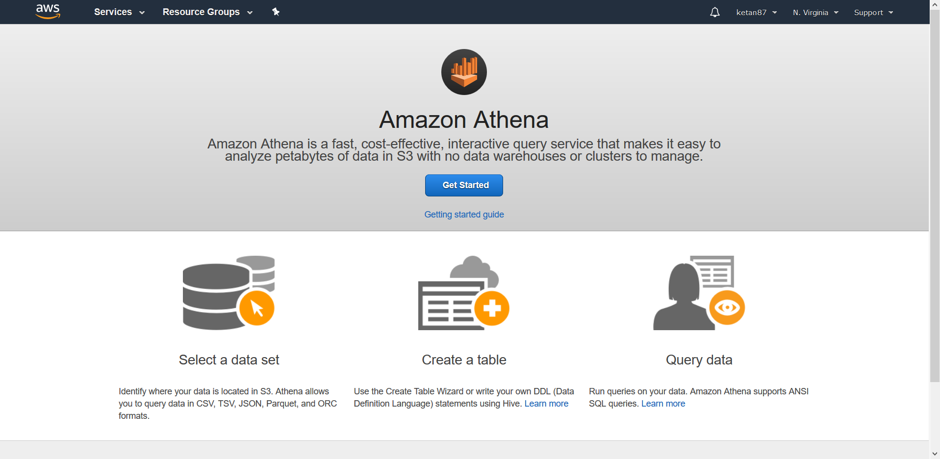

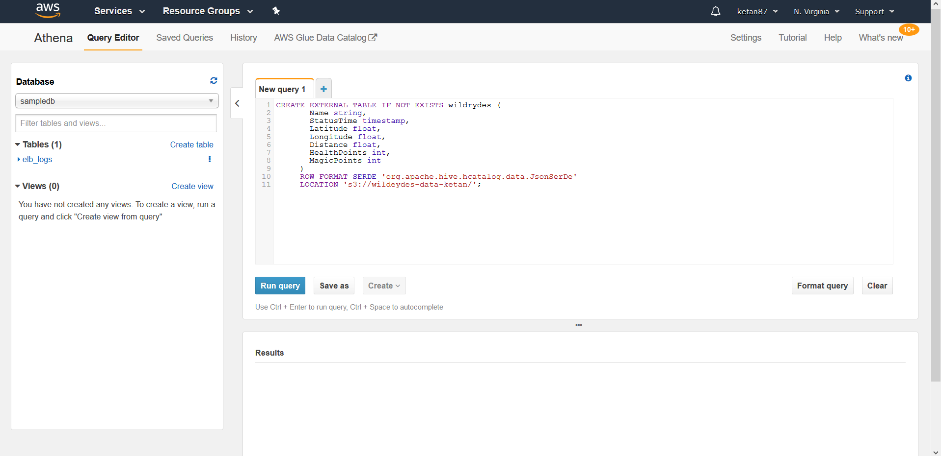

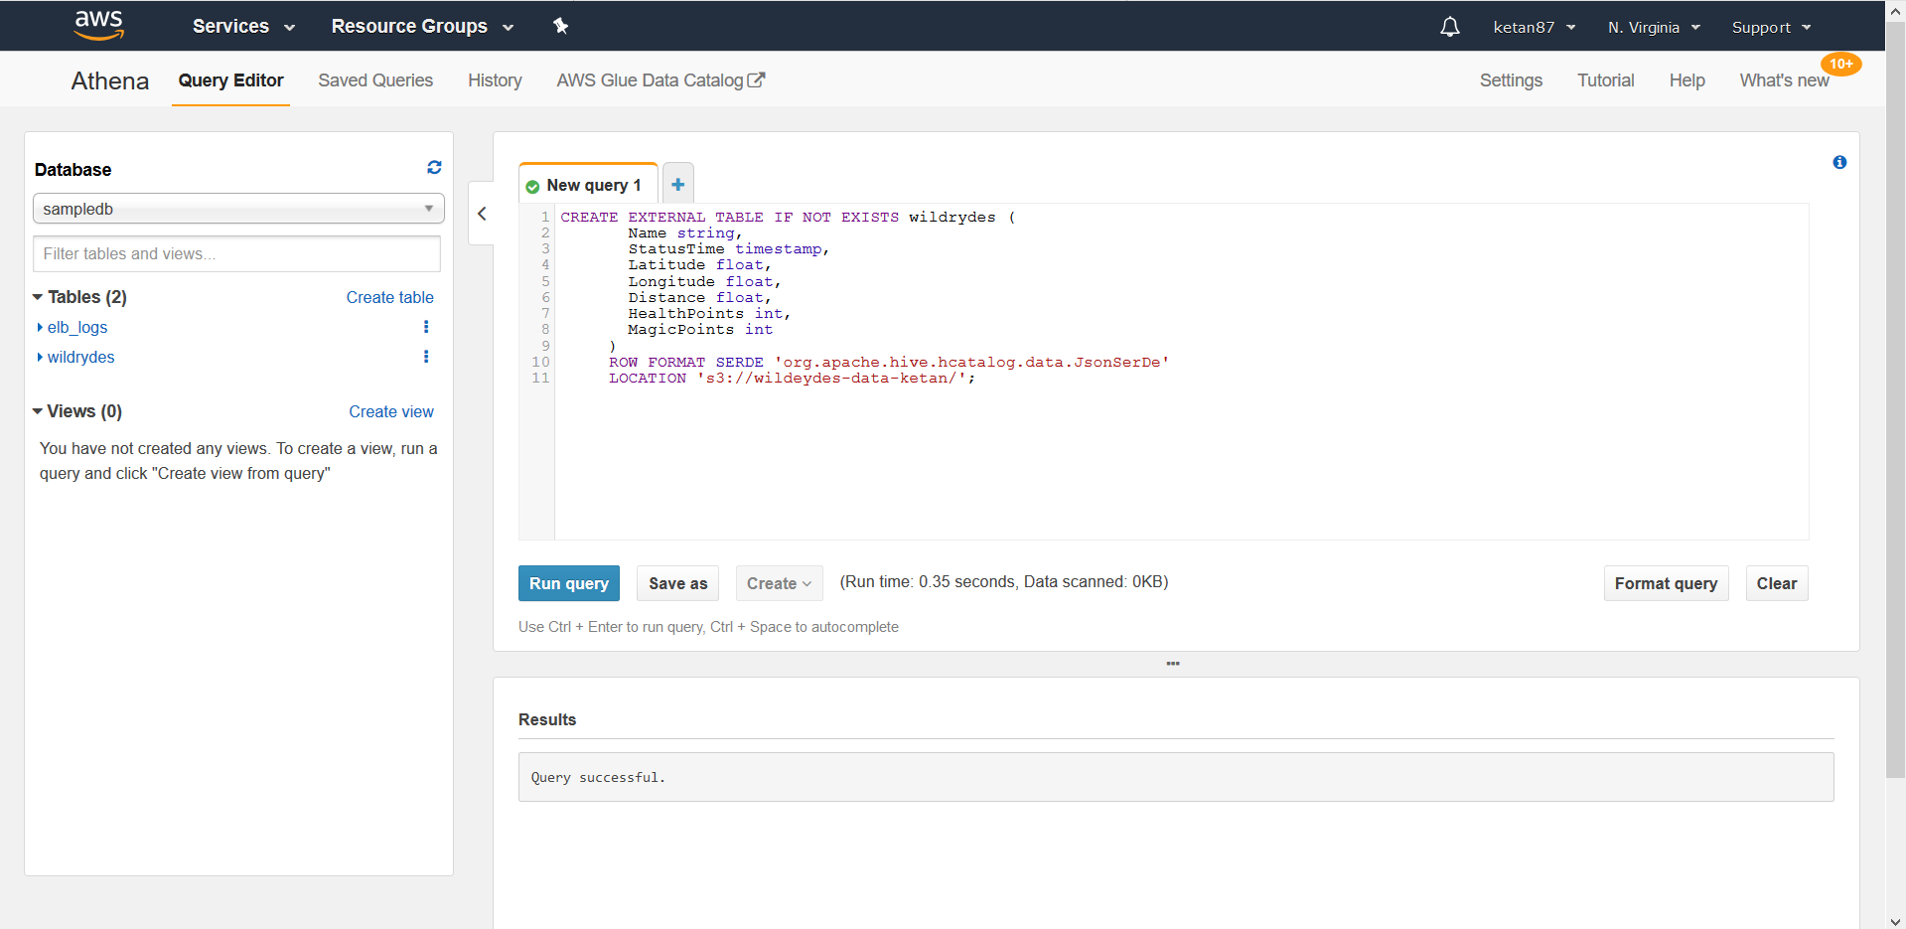

Explore the batched data files

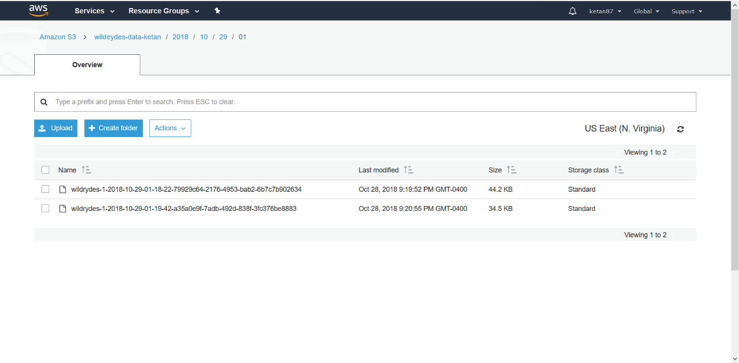

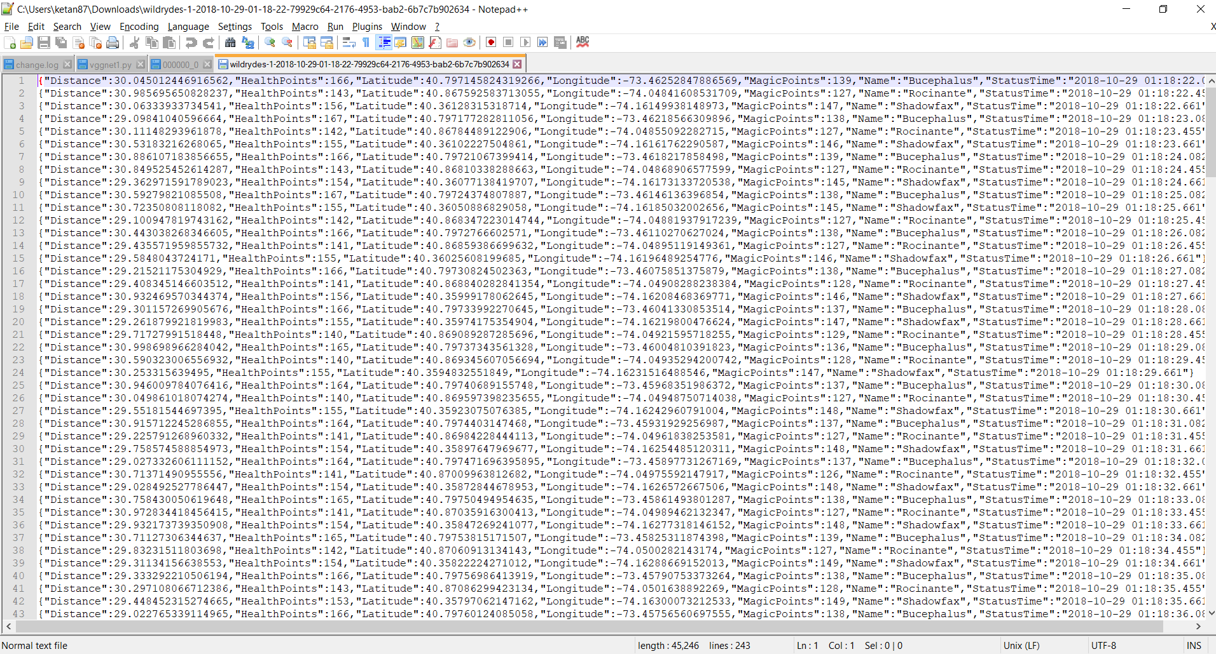

Query the data files

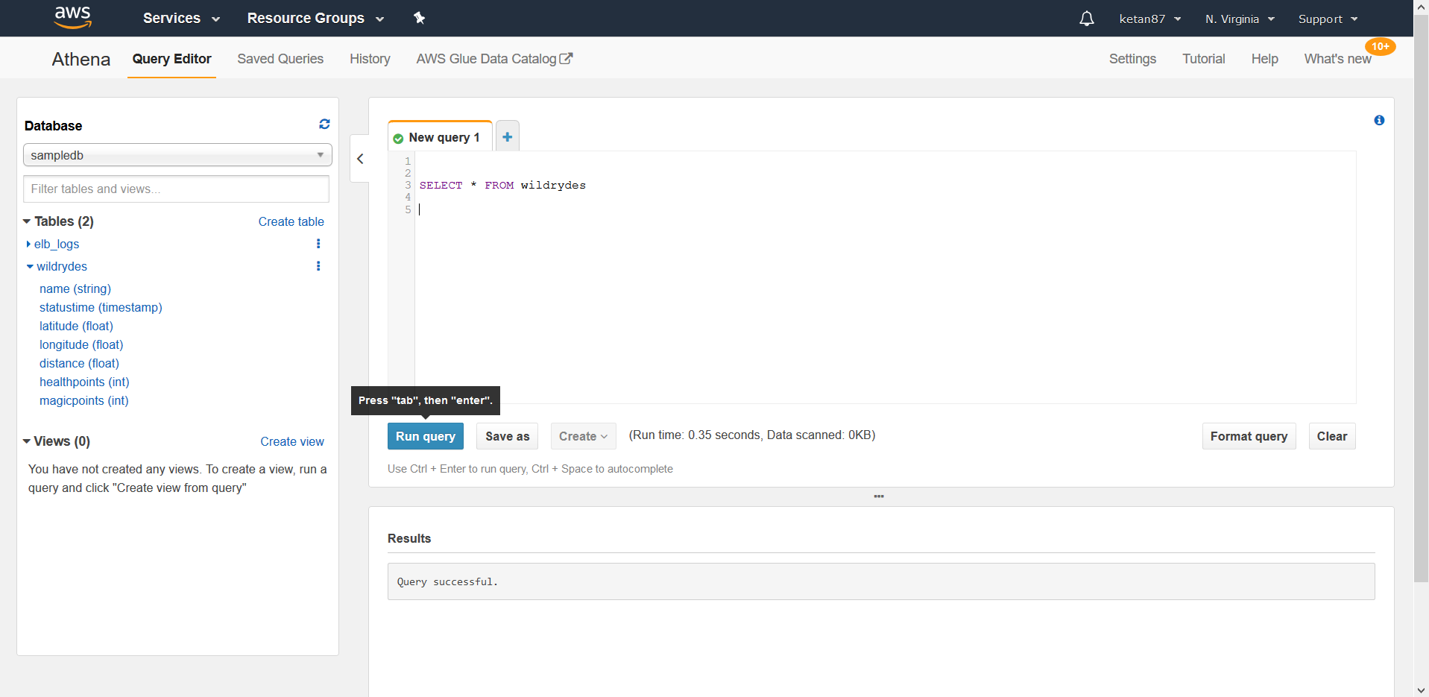

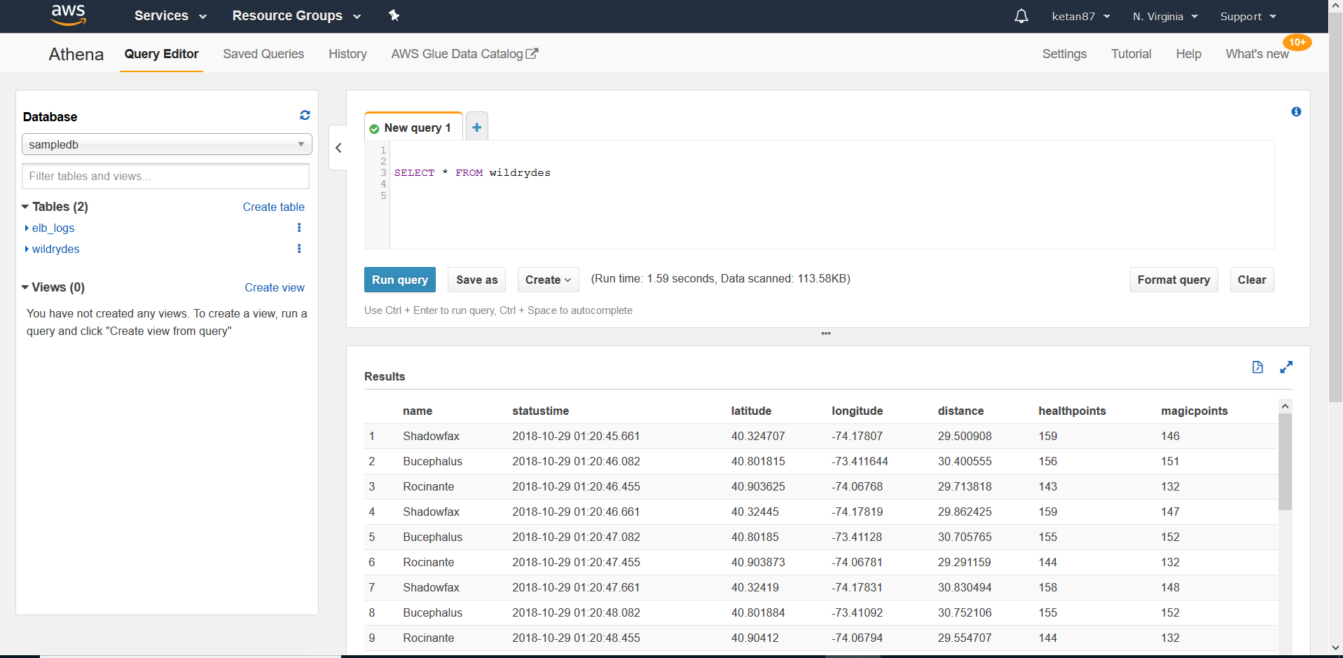

Thus, we have created a serverless real-time data processing app. This can be scaled almost on the go for your requirement. The biggest advantage of this architecture is the pay per use pricing.

Total Time 3 hours